**[GitHub - solegalli/feature-engineering-for-machine-learning: Code repository for the online course Feature Engineering for Machine Learning](https://github.com/solegalli/feature-engineering-for-machine-learning)**

Missing values- imputation

Imputation is act of replacing missing data

Goal of imputation: producing complete dataset used to train models

Numeric: mean/ median

Arbitrary value

End of tail

Categorical: freq category

Missing category

-Complete case analysis:

- adding a missing indicator

Random sample imputation

**Complete Case Analysis**

**Suitable for both categorical and numerical**

**Complete-case analysis (CCA),** also called "**list-wise deletion" of cases,** consists of **discarding** observations with **any** missing values. In other words, we only **keep observations with data on all the variables.**

**Which variables can I impute with CCA?**

CCA can be applied to **both categorical and numerical variables.**

**Assumptions**

CCA works well when the **data is missing completely at random**. In this scenario, excluding observations with missing information would be the **same as randomly excluding some observations from the dataset.**

**Therefore, the dataset after CCA remains a fair representation of the original dataset.**

**Advantages**

* **No data manipulation** required.
* **Preserves variable distribution** (assumming data is missing at random).

**Disadvantages**

* It **can discard a large fraction of the original dataset** (if missing data is abundant).
* **Excluded observations could be informative** (if data is not missing at random).
* CCA will create a **biased dataset** (i.e., the complete **dataset differs from the original data**) if the data is not missing at random.
* When using our models in production, the **model will not be able to handle missing data**.

**When to use CCA**

* Data is **missing completely at random**
* **No more than 5% of the total dataset contains missing data**

In practice, **CCA may be an acceptable method when the proportion of missing information is small. Missing proportion is small**

There is **no rule of thumb to determine how much missing data is small**. However, as general guidance, if the proportion of **missing data is <= 5%**, CCA could be a viable option.

**Models and CCA in production**

When using CCA, we remove all observations with missing information. **However, the data that we want to score with our model may indeed contain missing information**. This will **pose a problem when using our model in production:** when an observation contains **missing data, the model will not be able to handle it.**

Therefore, when putting **models into production**, we need to do 1 of 2 things:

either **we do not score observations with missing data**, or

we **replace the missing values with another value.**

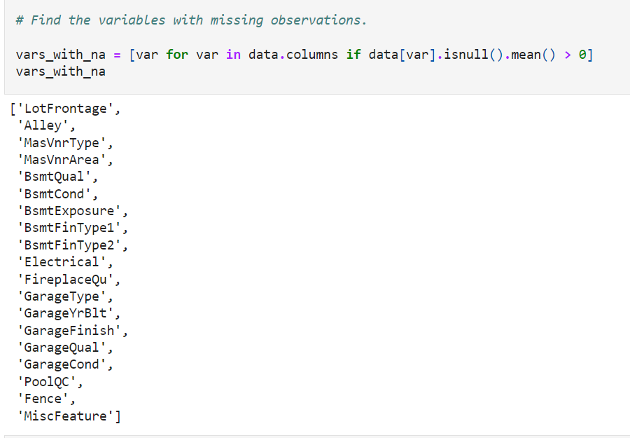

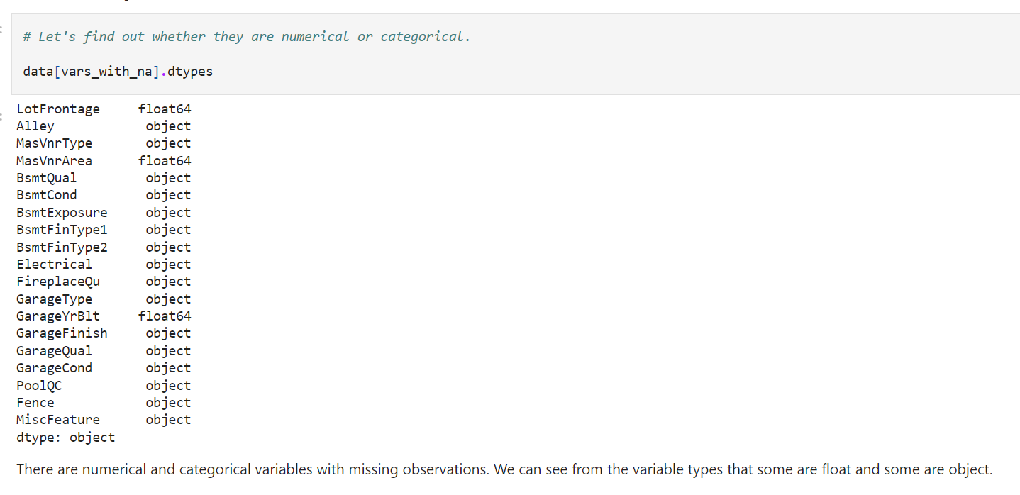

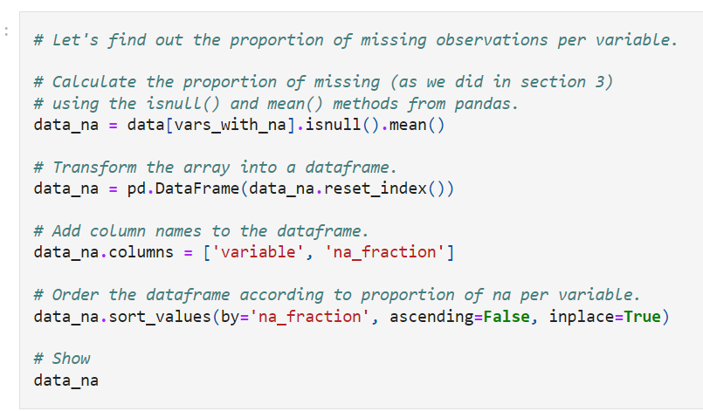

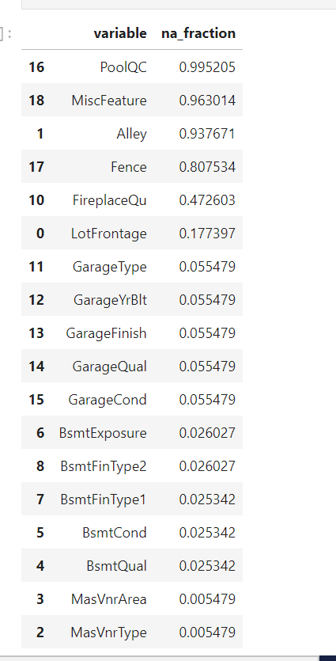

The first **6 variables contain a lot of missing information**,

so **we can't use CCA** if we consider those variables, **because we would discard most of the observations** in the dataset. We could use CCA if we omitted those variables.

For this demonstration, I'll skip the first six variables that have a lot of missing data and use CCA on the rest of the dataset.

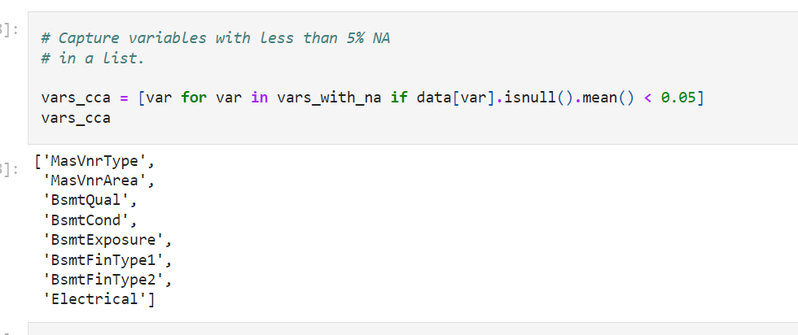

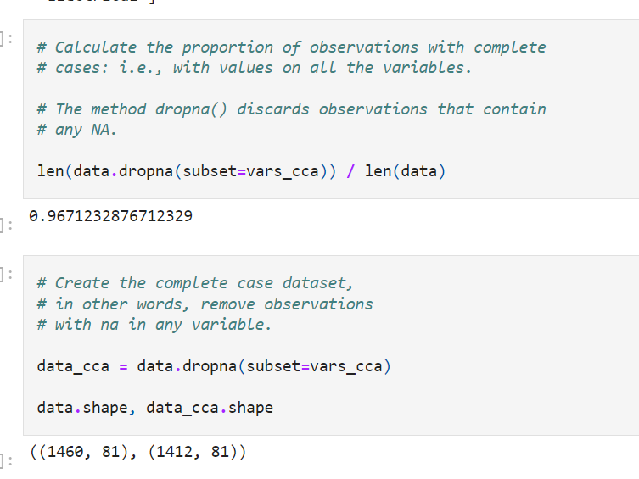

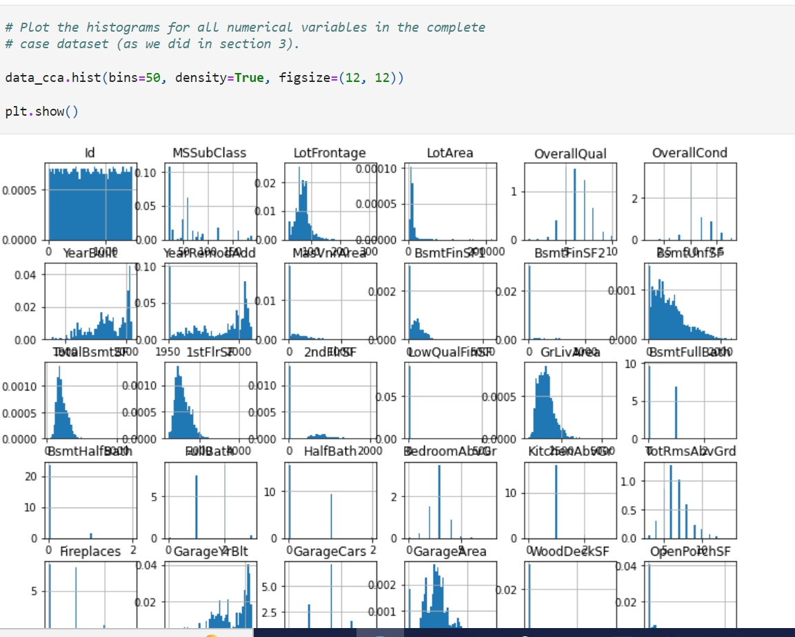

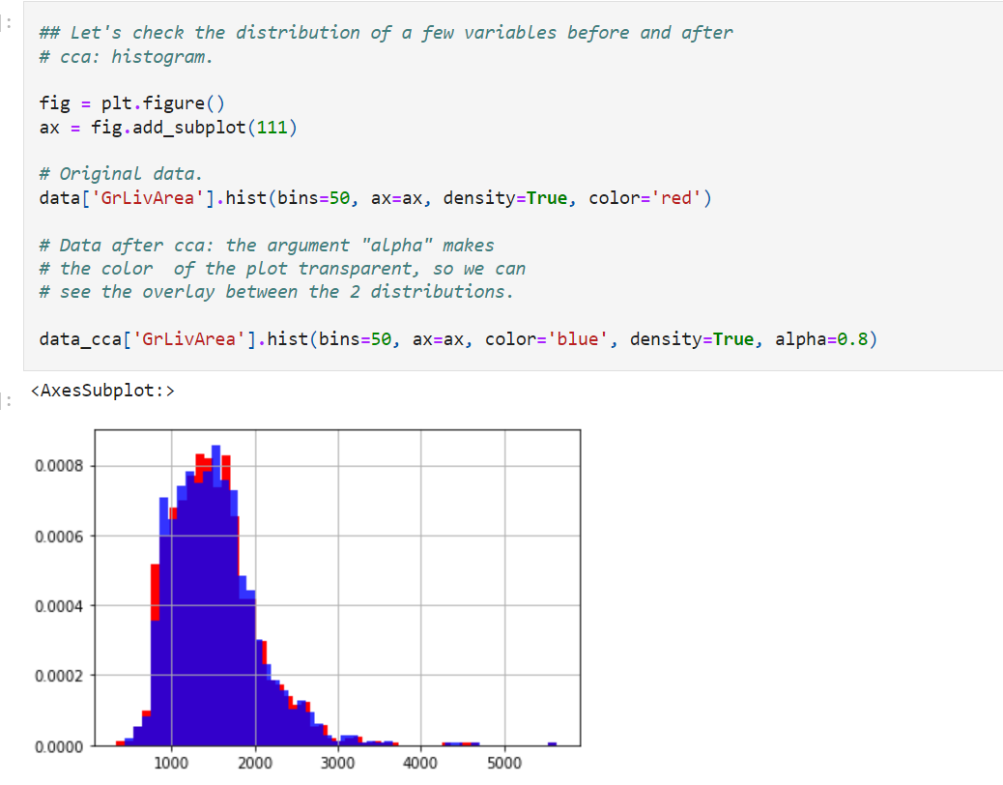

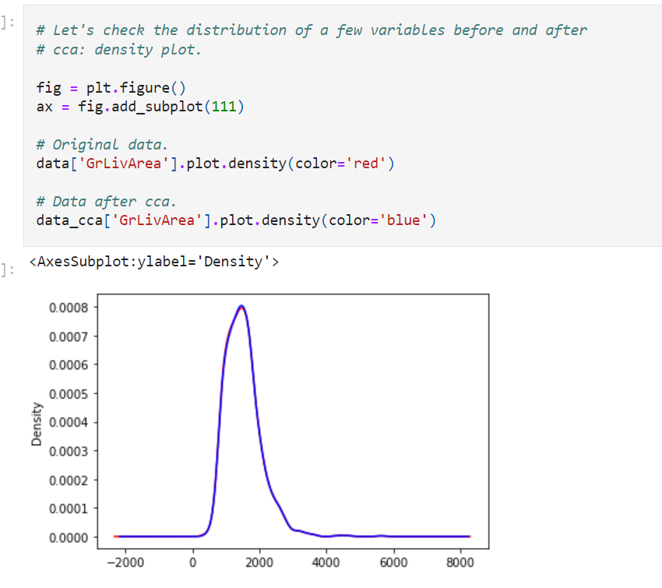

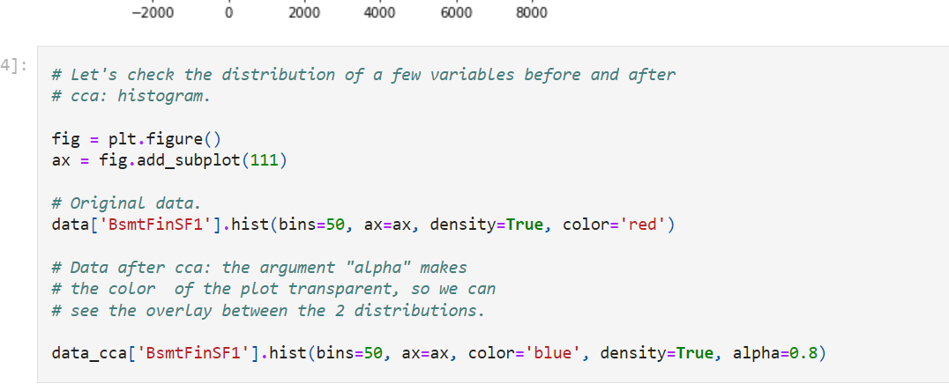

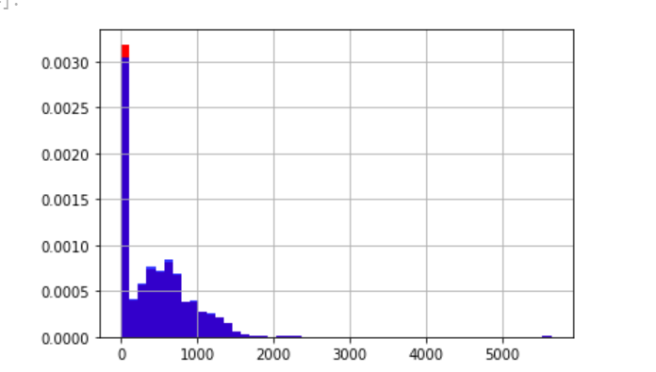

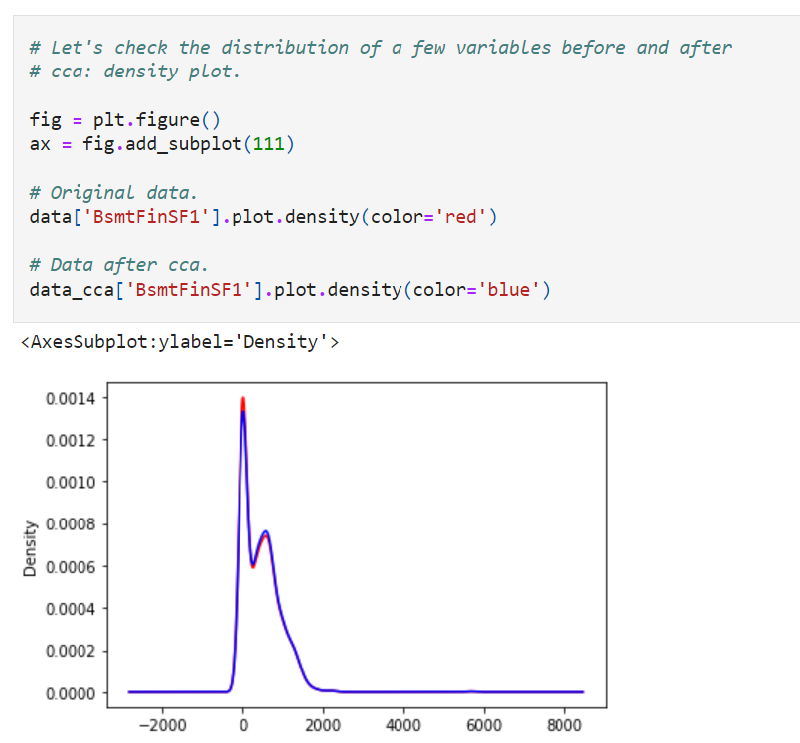

As we can see from the plots, the distribution of the **numerical variables in the original and complete case datasets is very similar,** which is what we expect from CCA when **data is missing at random.**

In the next few cells, I will explore the **distribution of categorical variables**. To do so, I will evaluate the percentage of observations that show each of the unique categories, as we did in sections 2 and 3 of the course.

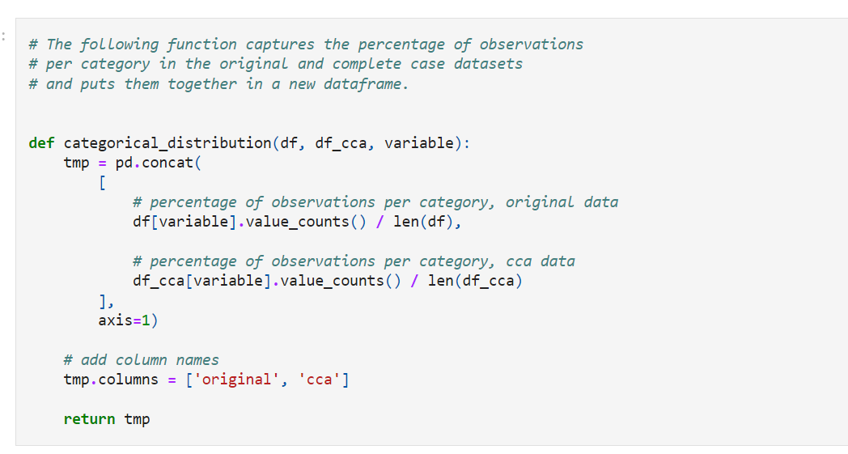

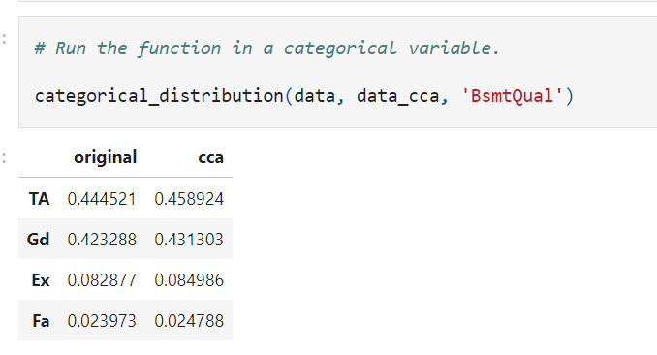

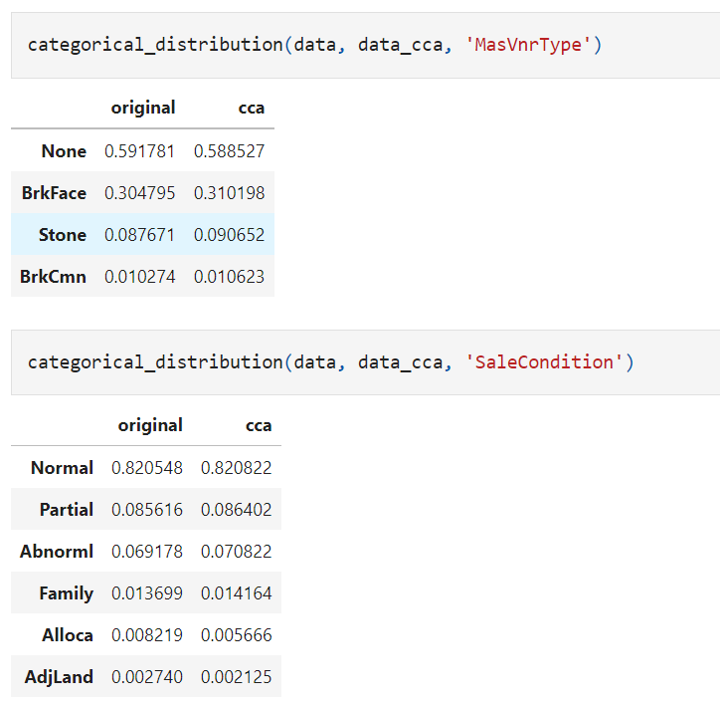

As we can see from the output of the cells above, **the distribution of houses in each of the categories is very similar in the original a**nd complete case datasets, which is what is expected if the data is missing completely at random.

**Mean / Median imputation**

Imputation is the act of replacing missing data with statistical estimates of **the missing values**. The goal of any imputation technique is to produce a **complete dataset** that can be used to train machine learning models.

Mean/median imputation consists of replacing all occurrences of missing values (NA) within a variable by **the mean (**if the variable has a **Gaussian distribution**) **o**

**r median (if the variable has a skewed distribution).**

**Note**:

If a variable is **normally distributed**, the **mean, median, and mode are approximately the same**. Therefore, replacing missing values by **the mean and the median are equivalent.**

If the variable is skewed, the **mean is biased towards values** at the **end of the distribution**. As a result, the **median represents the majority of the values in the variable better**.

Replacing missing data by the mode is not common practice for numerical variables.

**Which variables can I impute with mean or median imputation?**

The mean and median can only be **calculated on numerical variables**. Therefore, these methods are suitable for **continuous and discrete numerical variables** only.

**Assumptions**

* **Data is missing completely at random.**

If data is missing at random, it's safe to assume that the **missing values are extremely close to the mean or median of the distribution**, which is the value of the **majority of the observations.**

**Advantages**

* **Fast way of** obtaining complete datasets
* Can be **integrated into production** (during model deployment)

**Limitations**

* **Distortion of the original variable distribution** (if the fraction of **NA is large**):

**- Distortion of the variance**

**- Distortion of the covariance** with other variables of the dataset

If the proportion of **NA is large**, the variance of **the variable will be distorted** when it **is replaced with the mean or median, resulting in an underestimating of the variance.**

Estimates **of covariance and correlations** with other **variables may also be affected**. Because the mean or median value that now substitutes the missing data does not always retain the relation with the remaining variables, **mean or median imputation may change intrinsic correlations.**

Finally, "**concentrating" missing values at the mean or median** value may lead to **observations that are common occurrences** in the distribution **being picked up as outliers**.

**When should mean or median imputation be used?**

* **Data is missing completely at random**
* **No more than 5% of the variable contains missing data**

Although in theory, the above conditions should be met **to minimise the impact of this imputation technique**, in practice, mean / median imputation is very commonly used, even when data **is not MCAR** and the **fraction of missing values is large**. The reason behind this, is the simplicity of the technique.

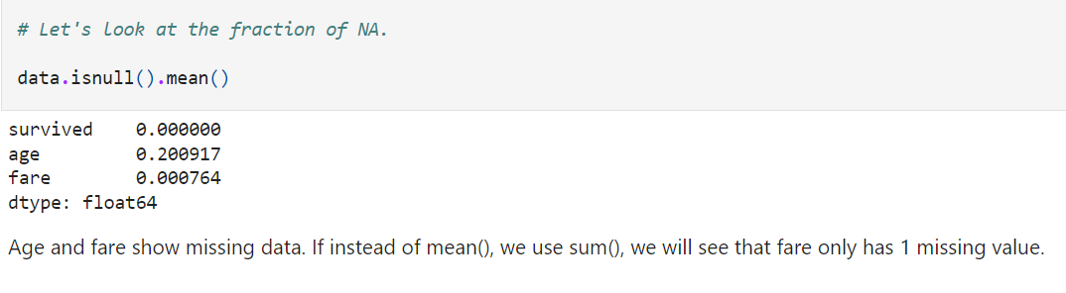

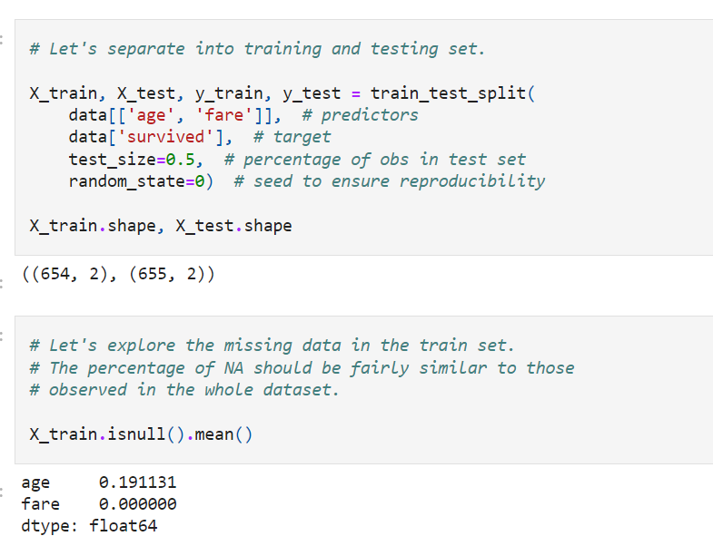

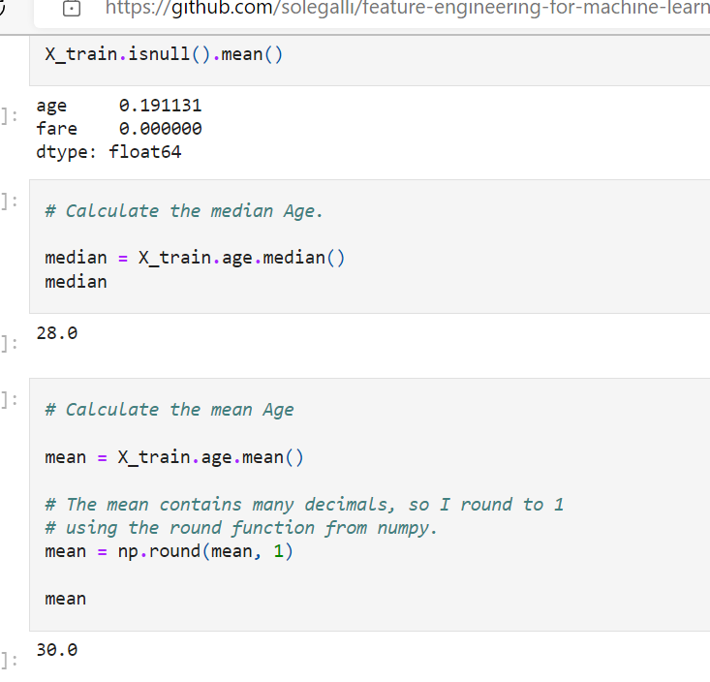

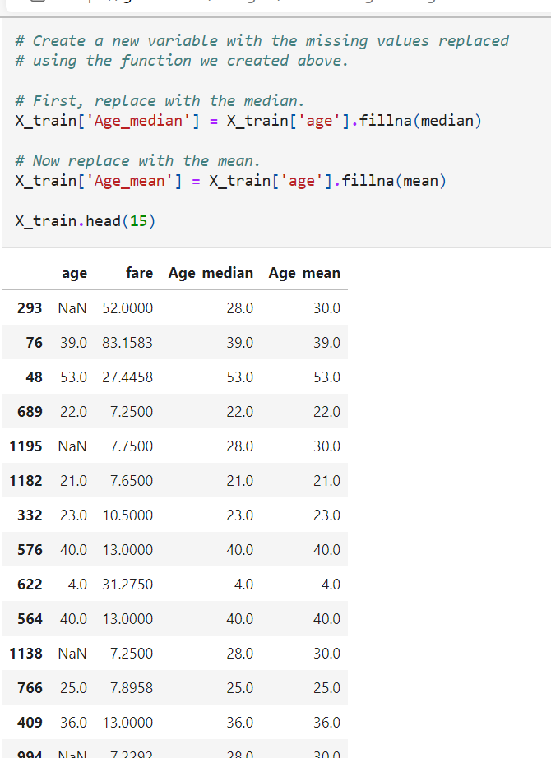

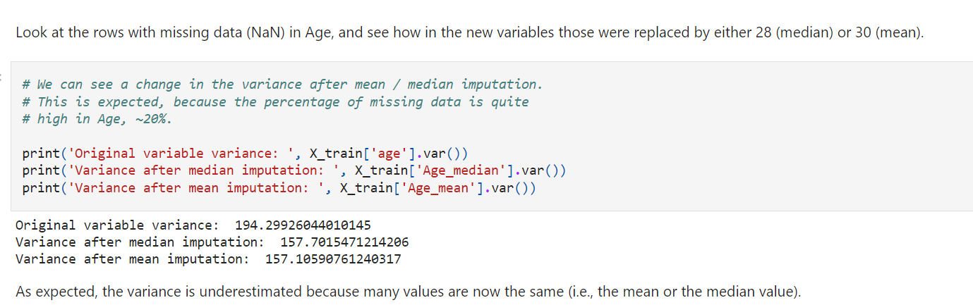

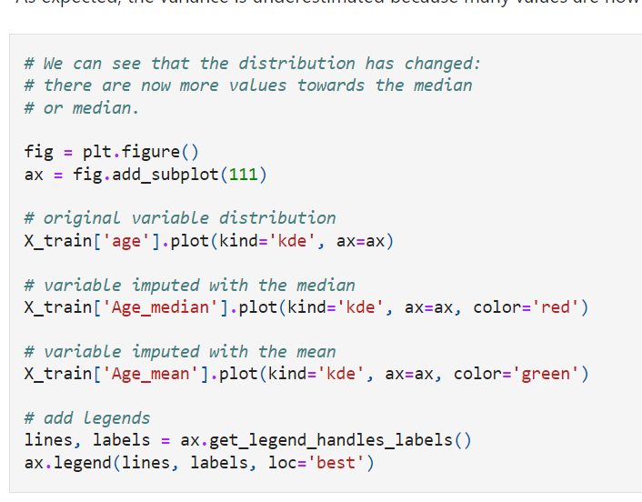

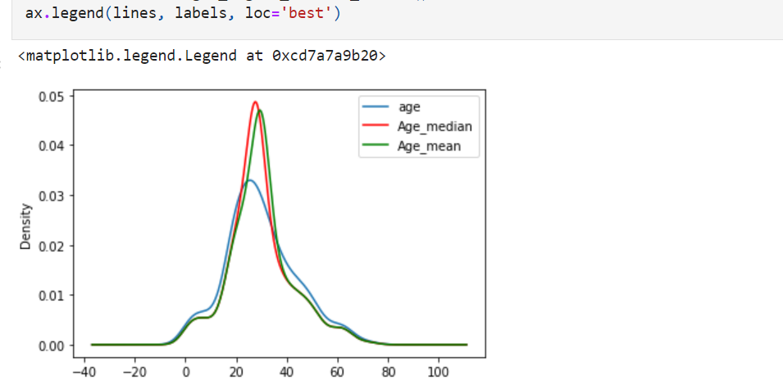

As mentioned previously, the mean / median imputation **distorted the original distribution of the variable Age.**

The transformed variable shows **more values around the mean / median values**.

**Is this important?**

It depends on the machine learning model you want to build**. Distorting the variable distribution may affect its relationship with the target**, which might be important for linear models. Therefore, the final imputed variable might **negatively affect the linear model's performance.**

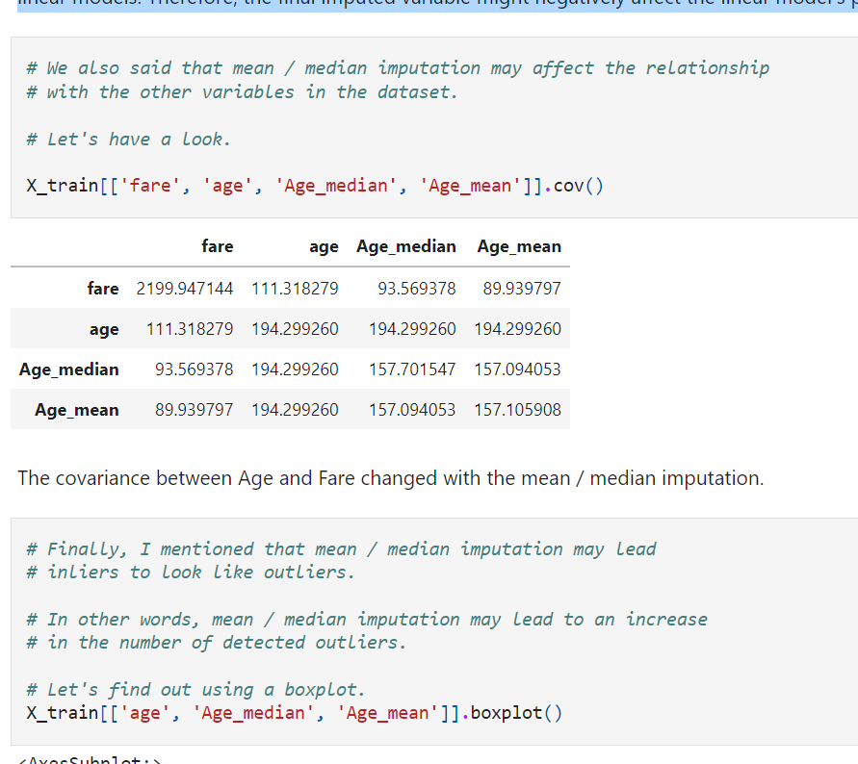

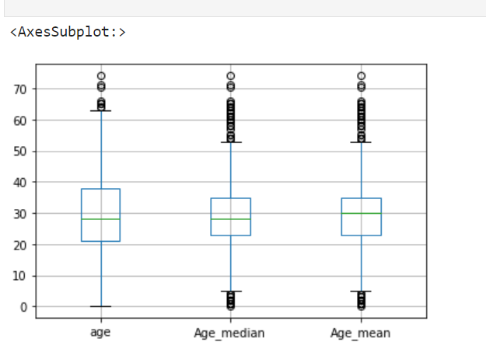

From the boxplot, we can see that after the imputation, **we not only have more outliers** at the higher age values, **but we now have outliers as well at the lower age values.**

**Is this important?**

If we are after true outliers, we need to keep this behavior in mind to make sure that **we are neither masking nor creating artificial outliers with our imputation** technique. In practice, we normally don't check for this behaviour at all. But I think it is important to know that it is happening.

**House Prices Dataset**

In this dataset, there are variables with a lot or with a few missing data points. Therefore, we can compare the effects of mean and median imputation in both cases.

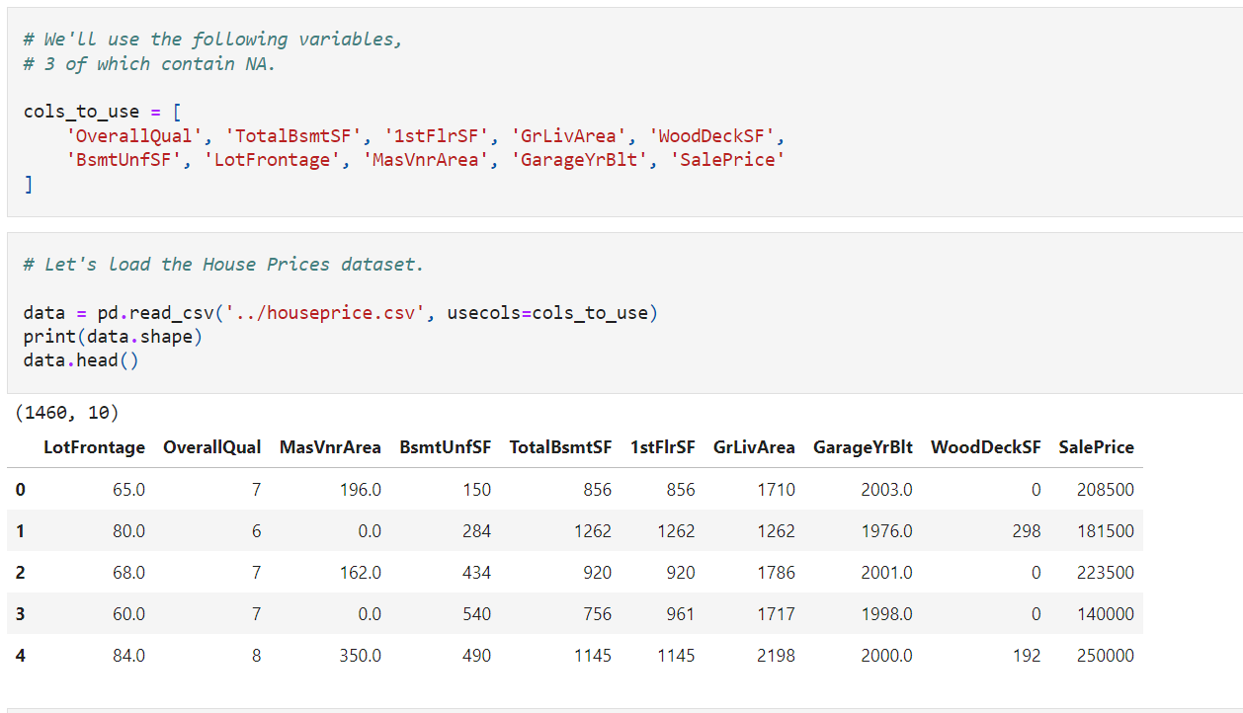

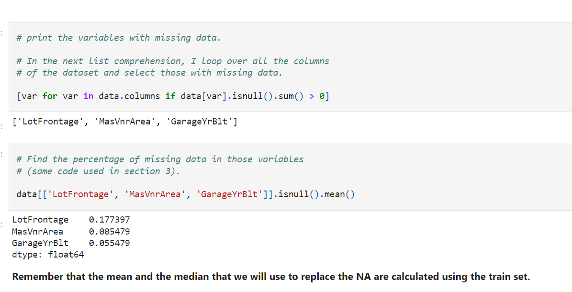

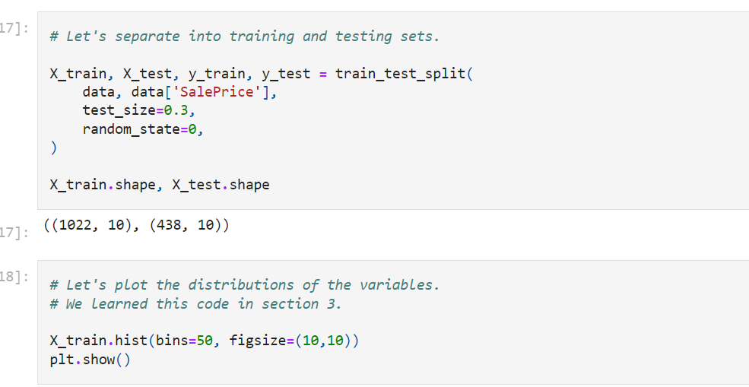

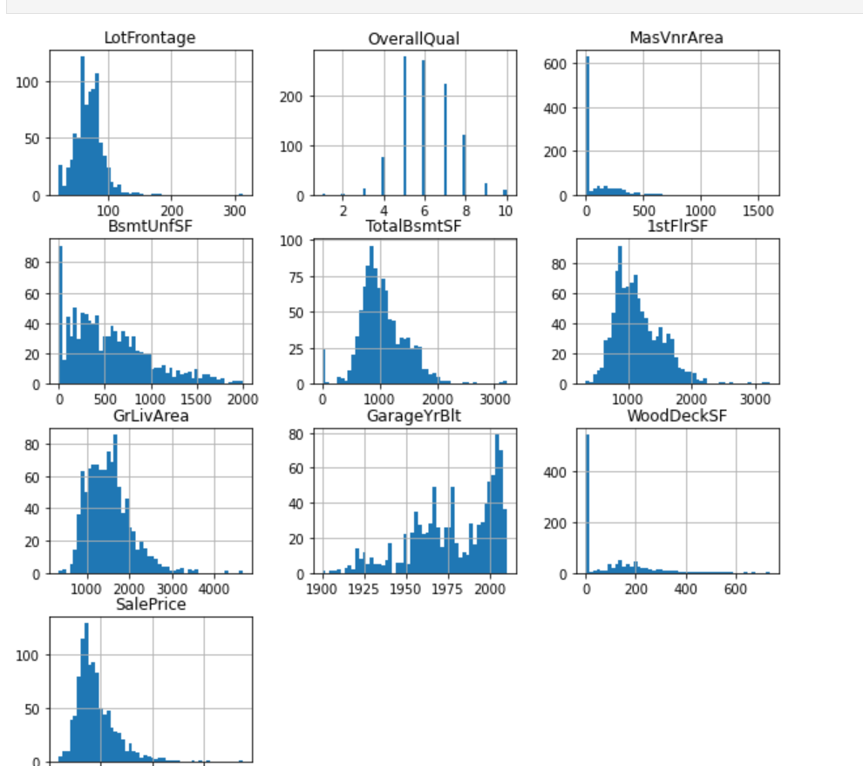

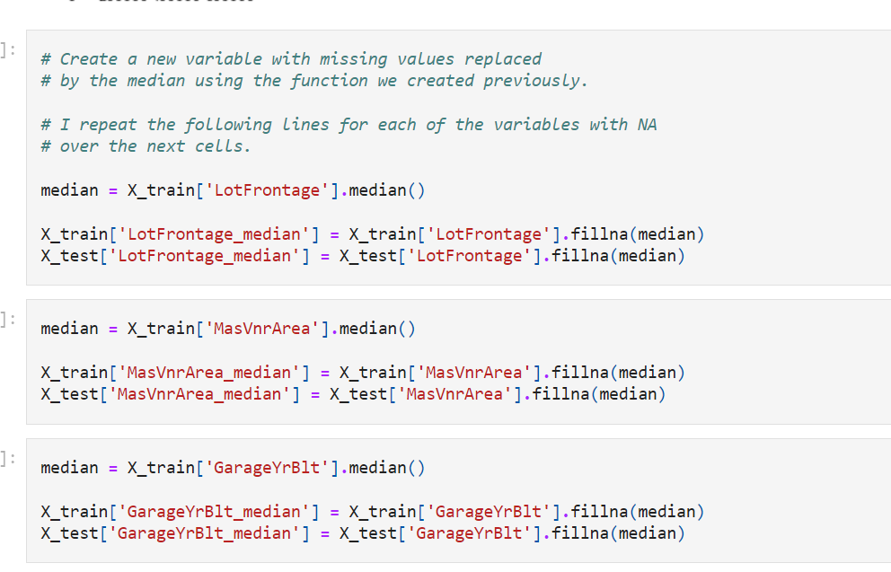

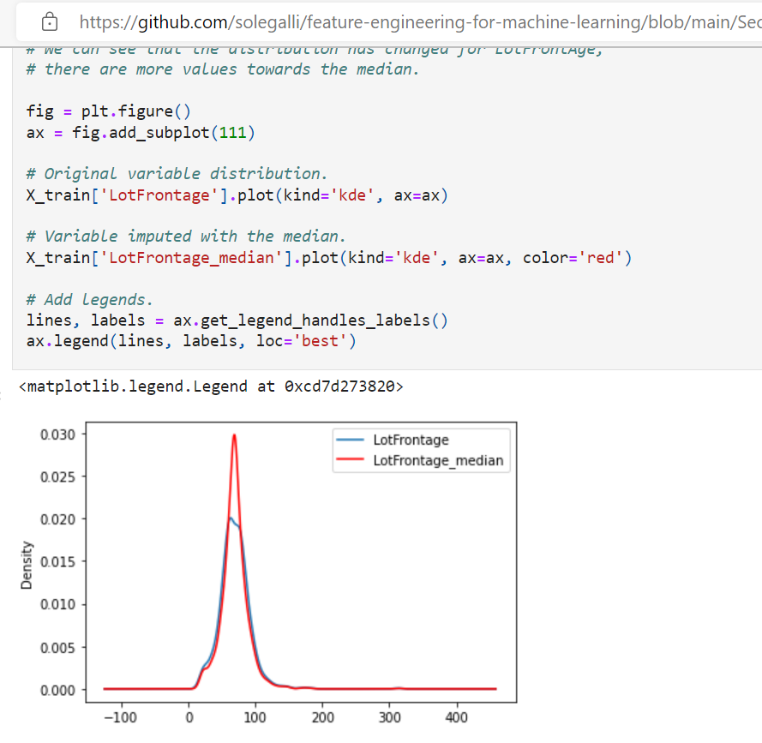

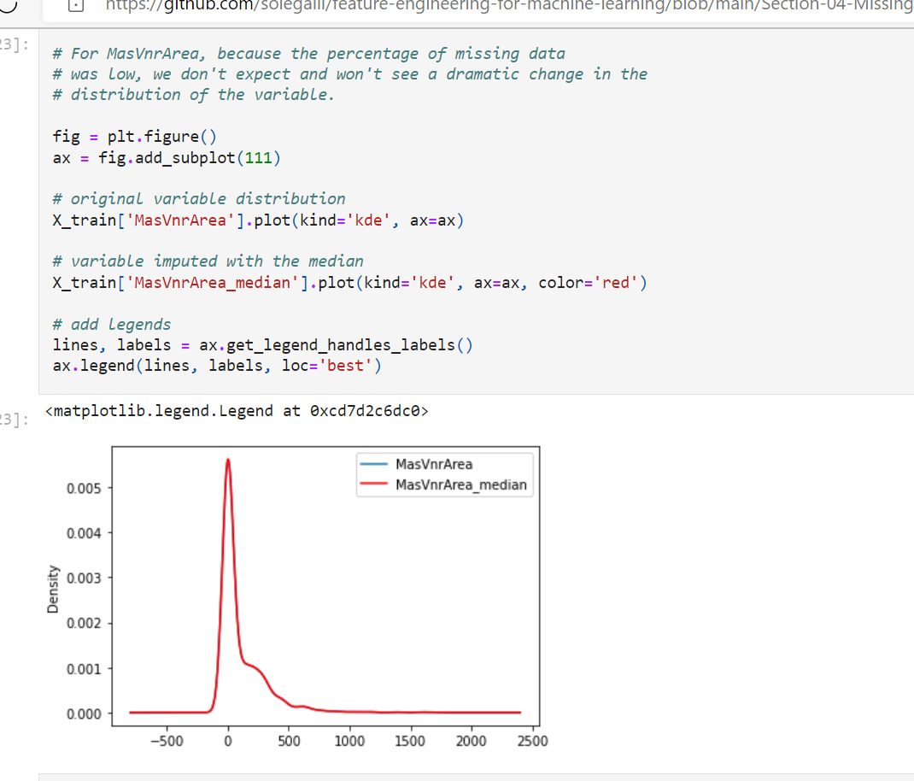

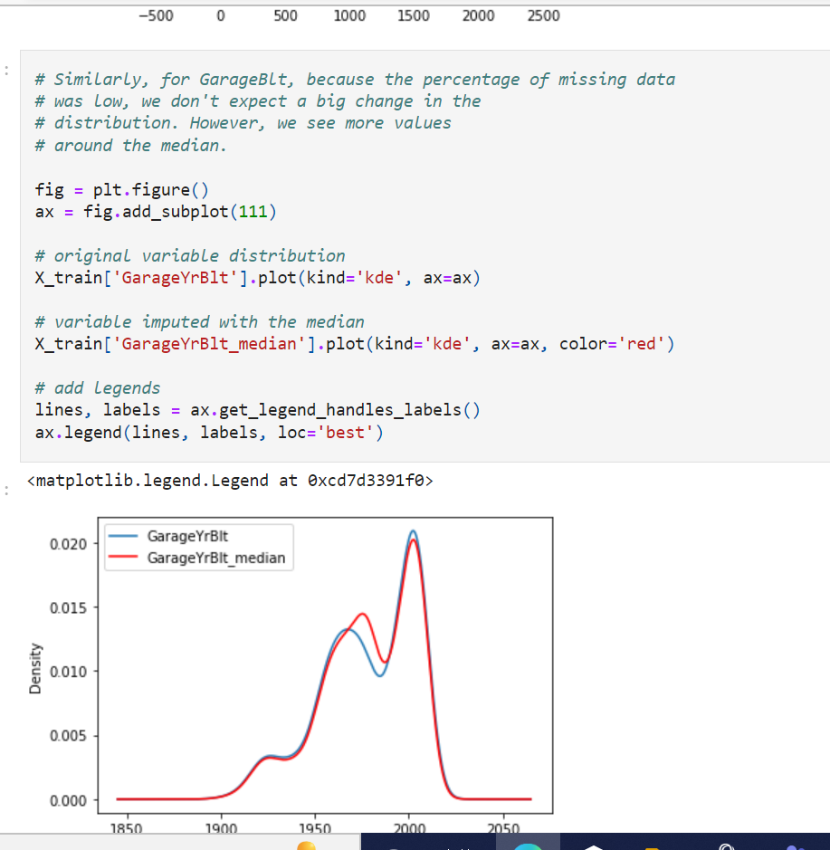

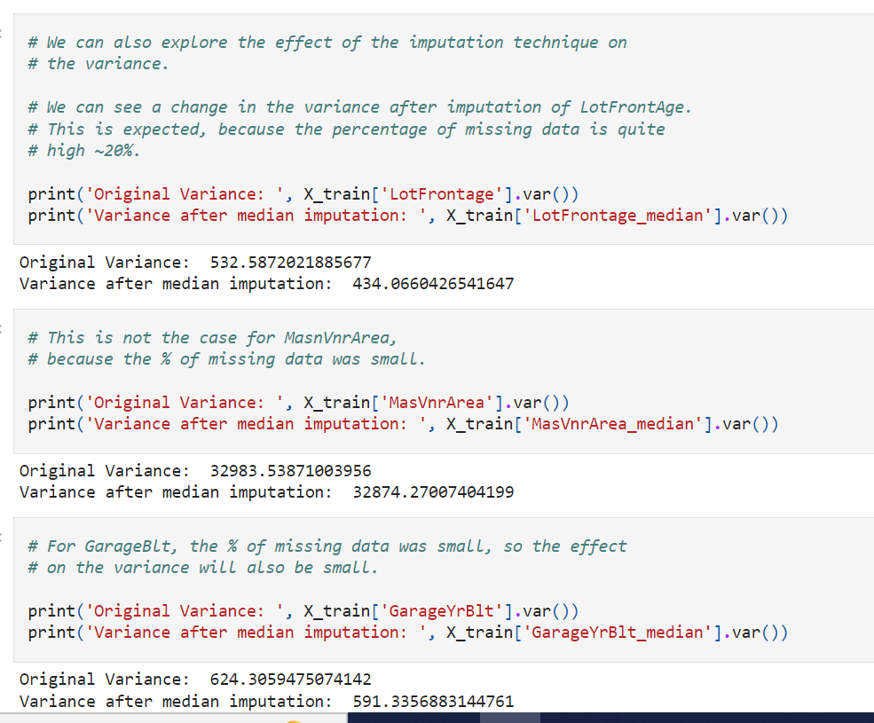

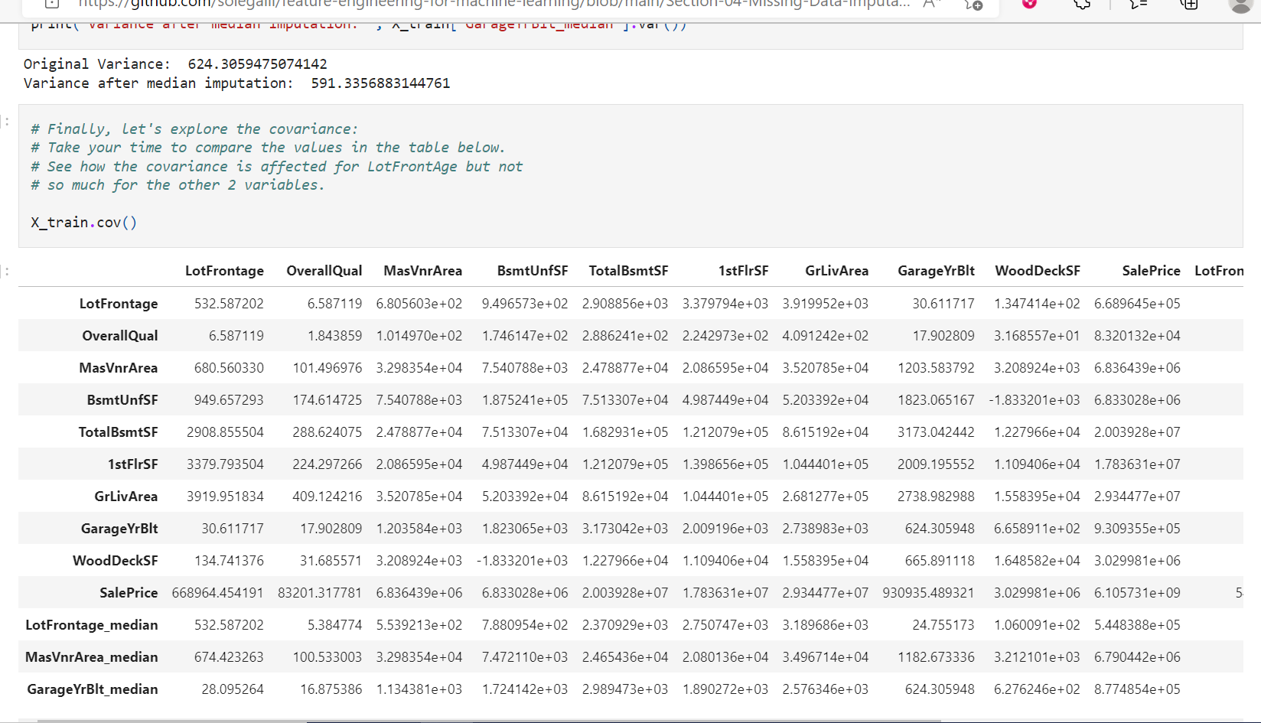

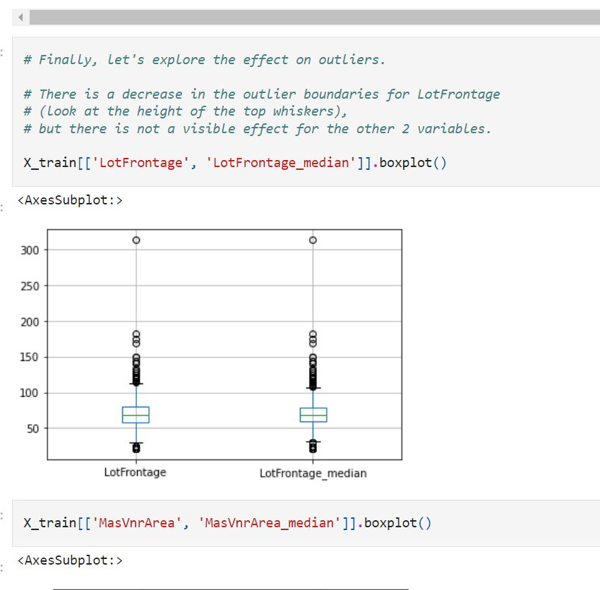

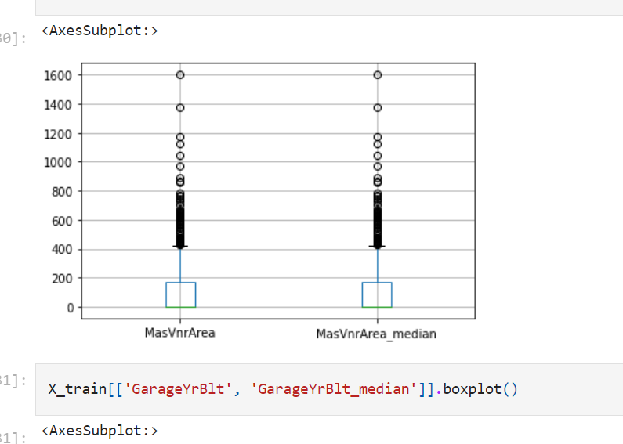

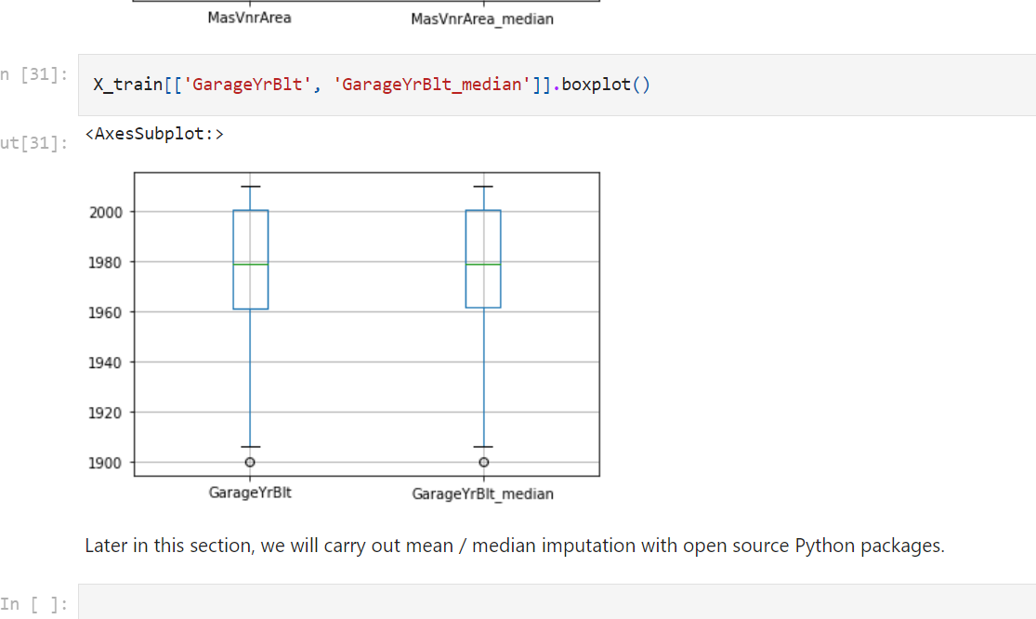

Suitable for numerical

**Arbitrary value imputation**

Imputation is the act of replacing missing data with statistical estimates of the missing values. The goal of any imputation technique is to produce a **complete dataset** that can be used to train machine learning models.

Arbitrary value imputation consists of replacing all occurrences of missing values (NA) with an arbitrary value. The most common values are 0, 999, -999 (or other 9 combinations), or -1 (if the distribution is positive).

**Which variables can I impute with an arbitrary value?**

Both categorical and numerical variables can be imputed with arbitrary values.

For categorical variables, this is the equivalent of replacing all instances of NA with an additional label, which is very common practice, so I will treat it separately in a future notebook.

**Assumptions**

* Data is not missing at random.

If this is the case, we want to flag the missing values with a different (arbitrary) value, instead of replacing those occurrences with the mean or the median, which represent the majority.

**Advantages**

* Fast way of obtaining complete datasets
* Can be integrated into production (during model deployment)
* Highlights missing observations

**Limitations**

* Distortion of the original variable distribution

    - Distortion of the original variance

    - Distortion of the covariance with the remaining variables of the dataset

* It may mask or create outliers
* Need to be careful not to choose an arbitrary value too similar to the mean or median (or any other common value of the variable distribution)

**When to use arbitrary value imputation**

Replacing the NA with **arbitrary values** should be used when **data is not missing at random**.

In this scenario, we would not like to replace it with the median or the mean, and therefore make the **NA look like the majority of our observations**. Instead, we want **to flag the fact that the observation is missing.**

This approach is widely used both in organisations and in Kaggle competitions. The challenge is deciding **which value to use for the imputation**.

**Final note**

When variables are captured by **third parties, like credit agencies**, they place arbitrary numbers to signal the fact that the **value for that observation is missing**. So, arbitrary value imputation is also common practice in real-life data collections.

With arbitrary value decided by user

0,999,-999

Both numerica and category

In category- we place new label missing

Ideally end of distributed values

They should not look like majority of values

Lim:

Distort :

Distri

Variance

Co variance

If missing value- end of dist value- creates outlier

Higher miss- high distortion

Shouldn’t take data similar to all other

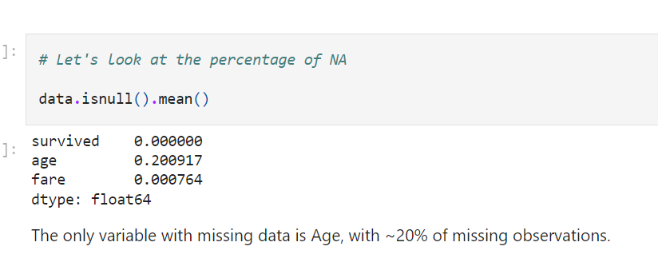

The only variable with missing data is Age, with ~20% of missing observations.

**Imputation important**

Imputation should be done **over the training set**, and then **propagated to the test set**.

For arbitrary value imputation this is not so important, because we chose the value arbitrarily, however it is good to adhere to this practice and **select the arbitrary value by looking only at the distribution of the variables in the train set.**

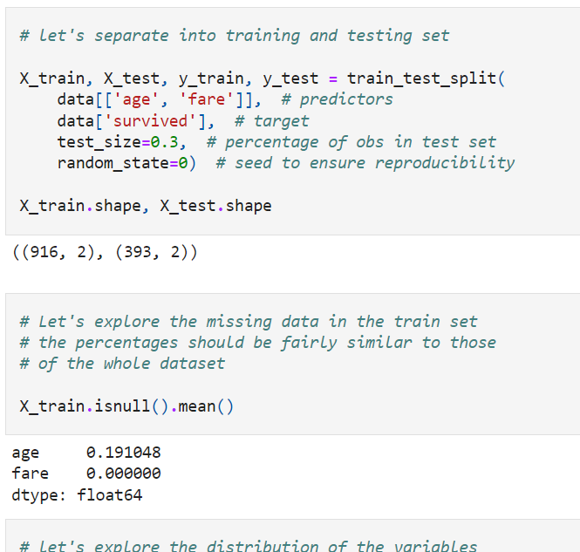

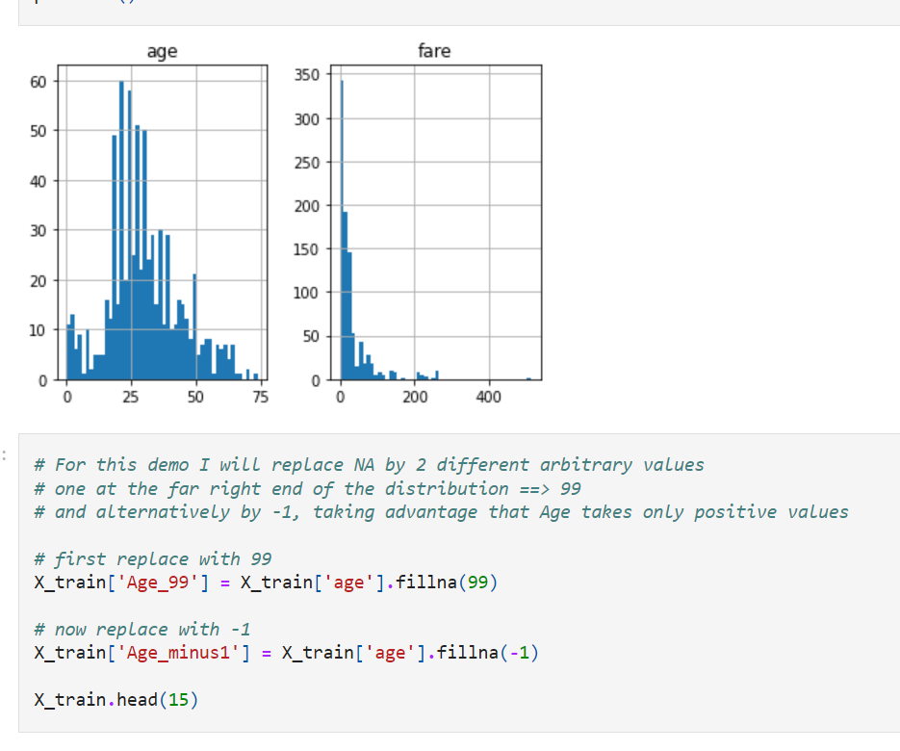

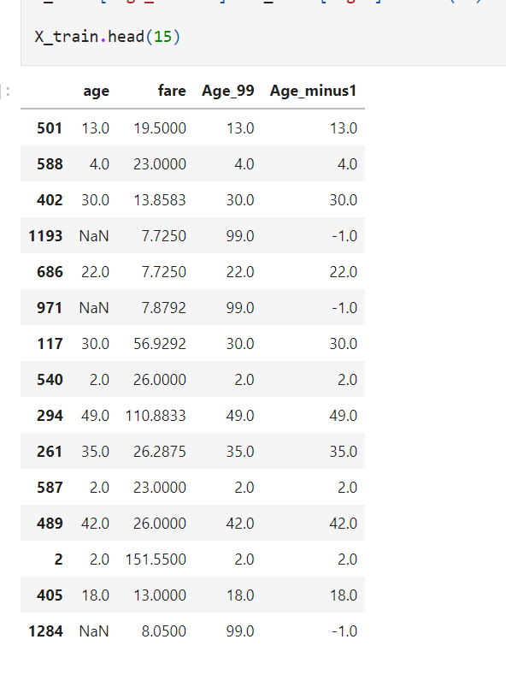

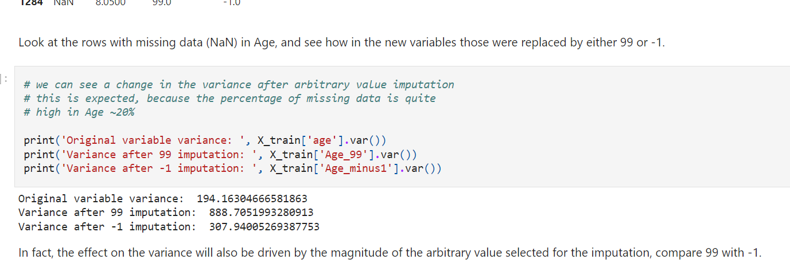

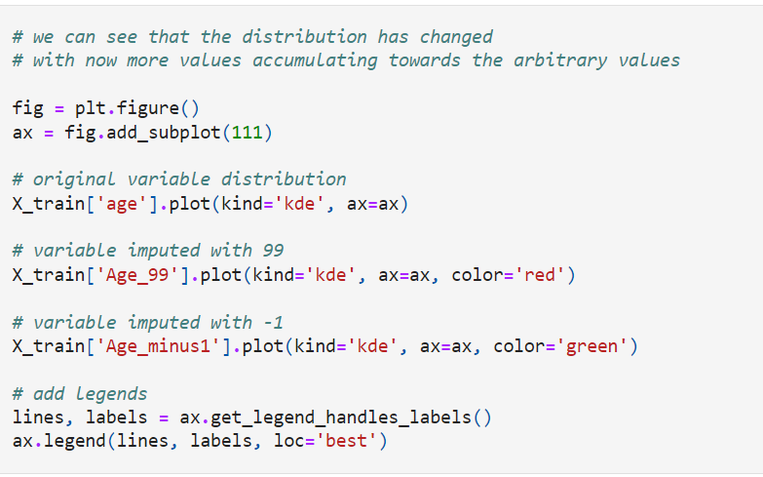

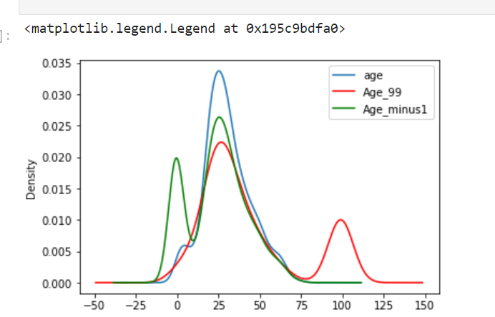

As mentioned above, **arbitrary value imputation distorts** the **original distribution** of the variable Age. The transformed variable shows more values around arbitrary values.

**Is this important?**

It depends on the machine learning model you want to build. Linear models assume that the **variables are normally distributed**. Arbitrary value imputation may distort the original normal distribution if the percentage of missing data is high. Therefore, the final imputed variable will no longer be normally distributed, which in turn may affect the linear model performance.

On the other hand, **this technique works quite well with tree-based algorithms.**

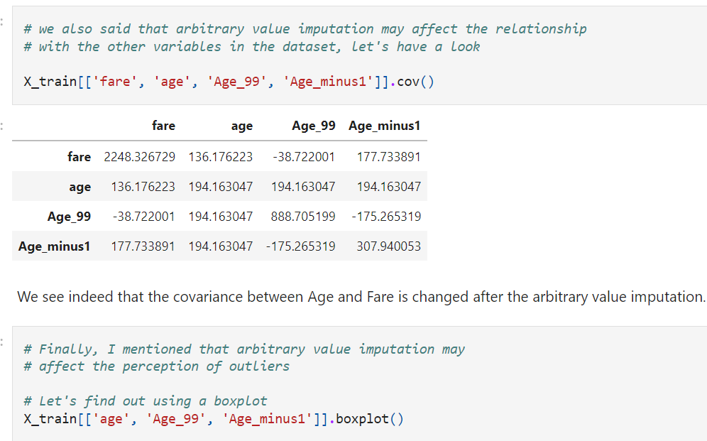

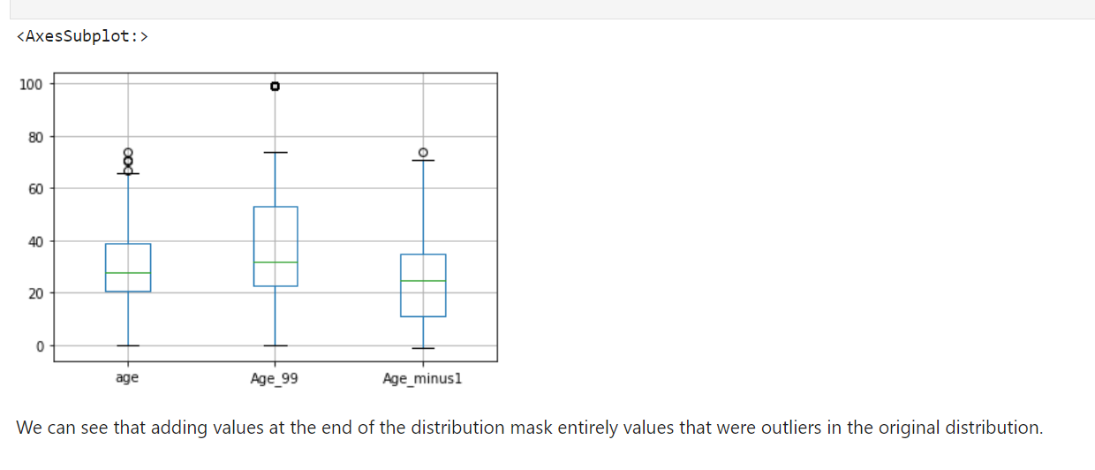

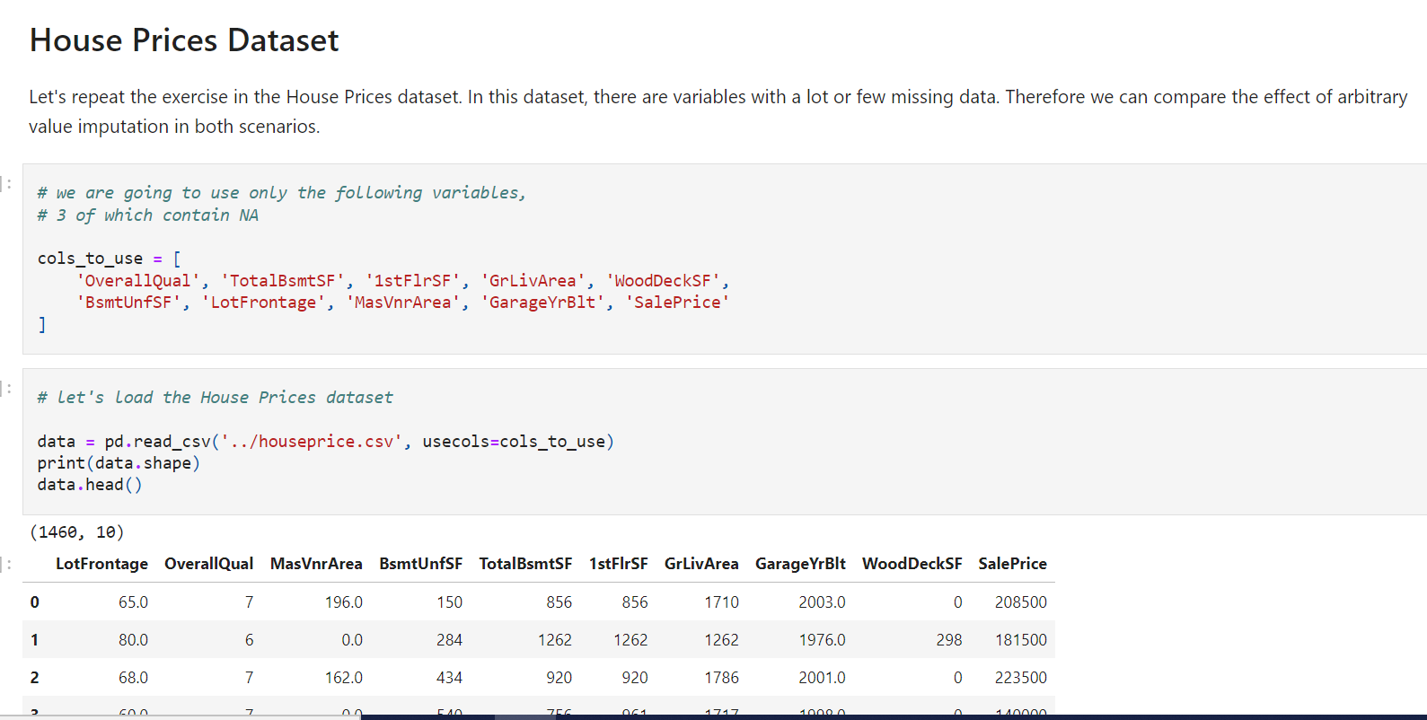

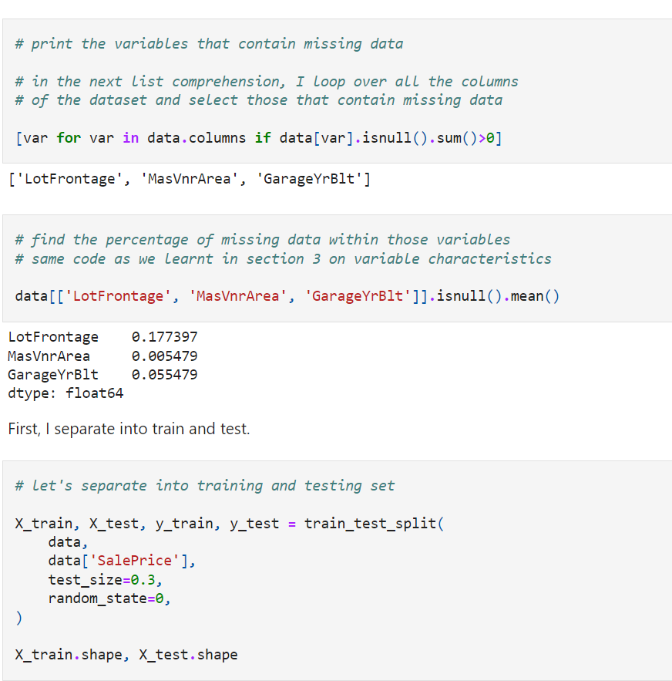

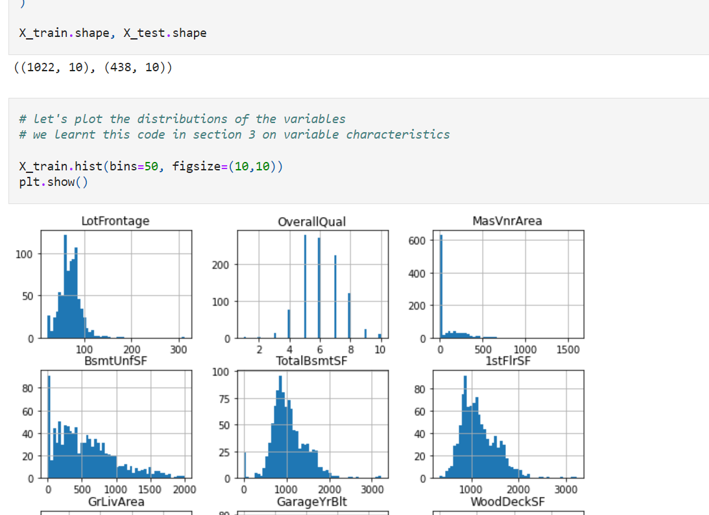

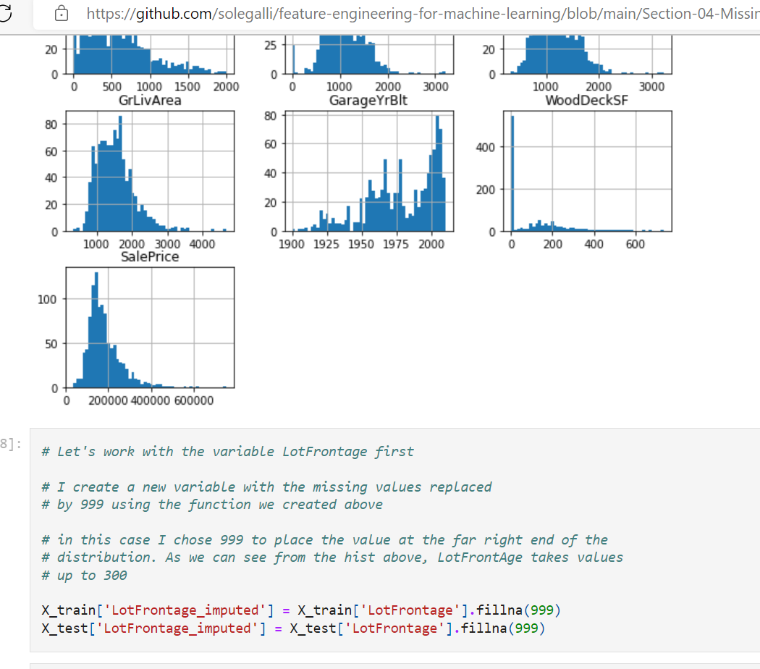

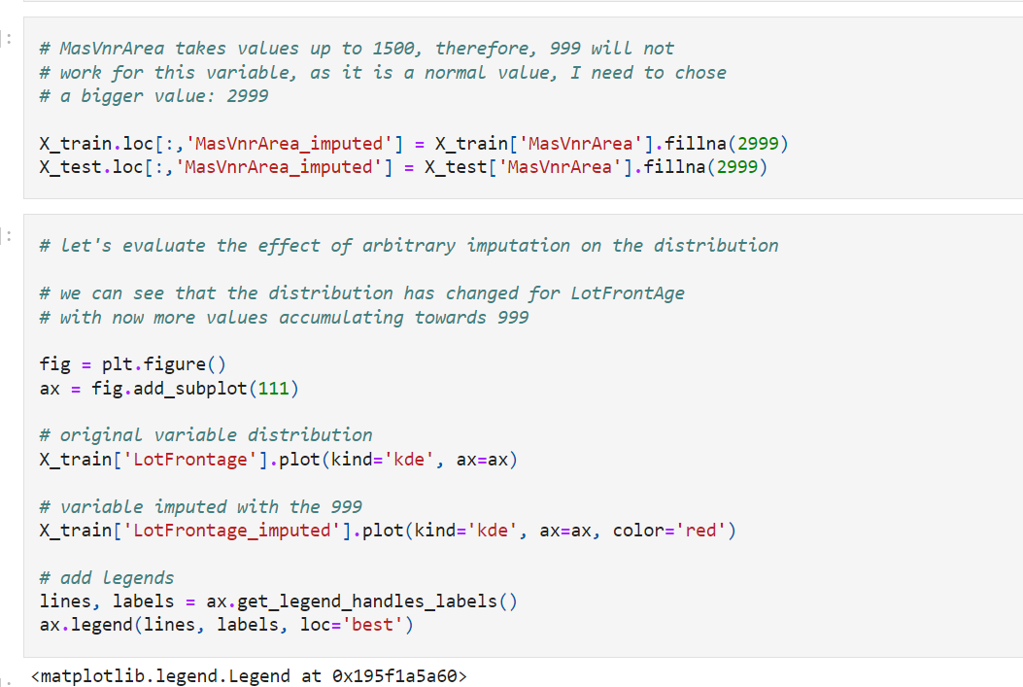

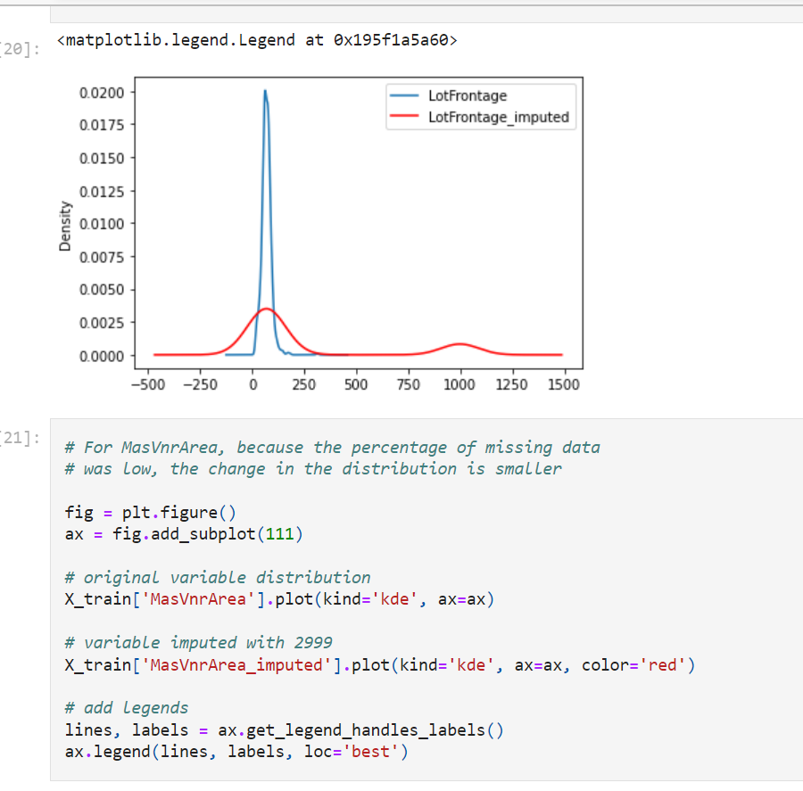

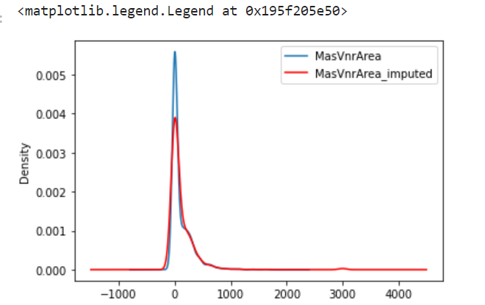

From the plots, we can see that **the distribution of LotFrontAge has changed quite dramatically**, but **not so much the distribution of MasVnrArea**.

This is because the **percentage of missing values in the second variable is quite small**. However, the distribution will be impacted more or less depending on the arbitrary value you choose to replace the NA.

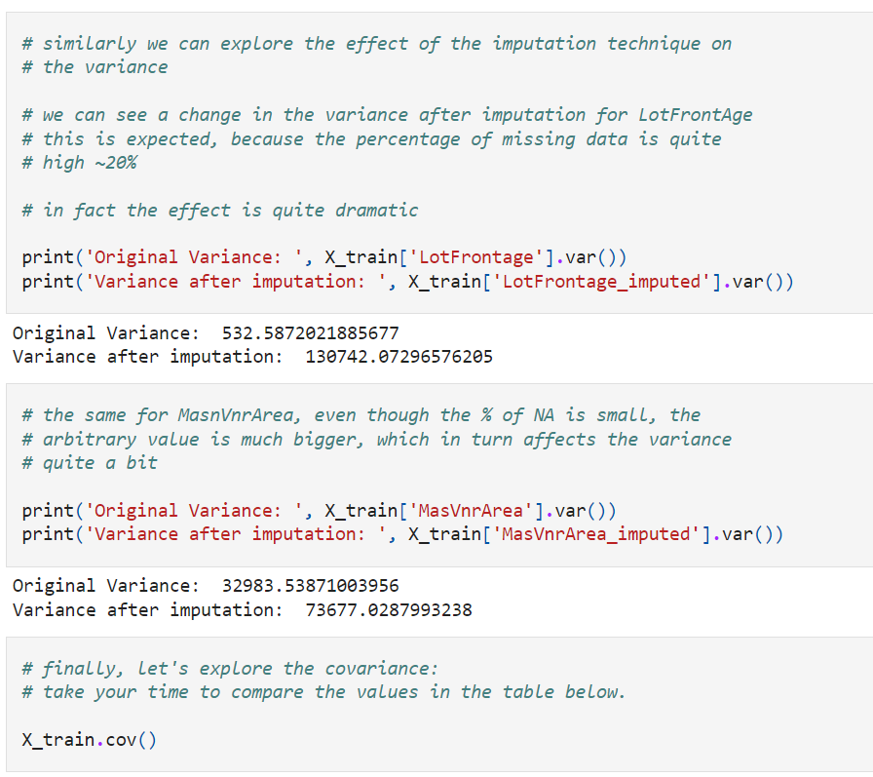

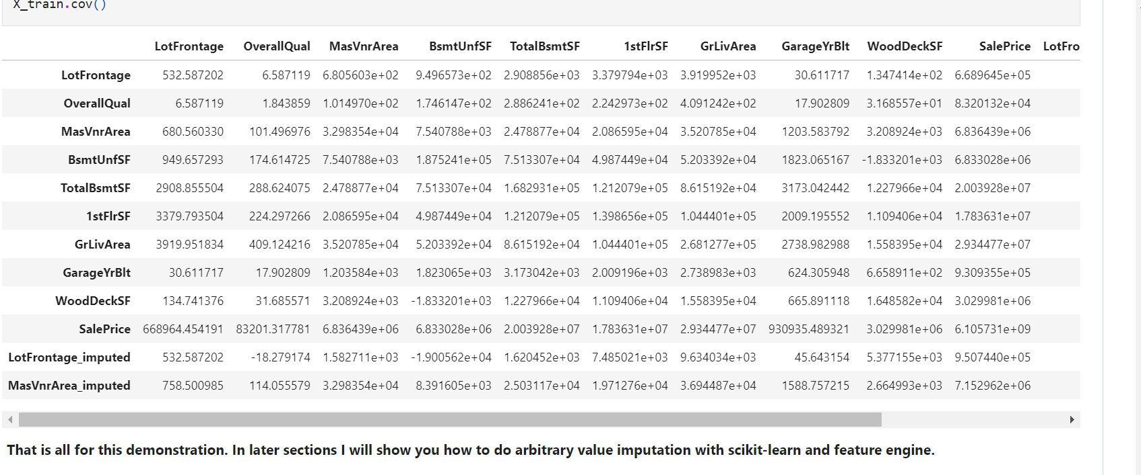

**End of distribution imputation**

By selecting arbitrary values at the end of the variable distribution, we can automate this operation.

**How do we select the value at the end?**

* If the variable is normally distributed, we can use **the mean plus or minus 3 times the standard deviation**
* **If the variable is skewed,** we can use the **IQR proximity rule**

We learned these techniques in section 3, in the lecture on "Outliers".

* We can also select the min/max value and multiply it by a factor, like 2 or 3.

**Which variables can I impute with an arbitrary value?**

This method is suitable for **numerical variables.**

**Assumptions**

* Data is **not missing at random**

If the value is **not missing at random,**

**we don't want to replace it with the mean or median** and therefore make that observation look like the majority of the observations.

Instead, **we want to flag that observation**, and therefore we assign a value at the tail of the distribution, which is **not a common occurrence.**

**Advantages**

* Fast way of obtaining complete datasets
* Automates arbitrary value imputation
* Can be integrated into production (during model deployment)
* Highlights missing data

**Disadvantages**

* Distortion of the original variable distribution

    - Distortion of the original variance

    - Distortion of the covariance with the remaining variables of the dataset

* This technique may mask true outliers in the distribution

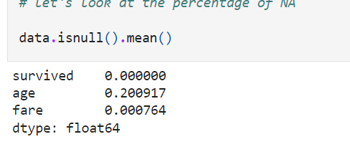

**Imputation important**

**Imputation has to be done over the training set**, and then **propagated to the test set**. For this imputation technique, this means that when selecting the value with which we will replace the NA, we need to do so only by **looking at the distribution of the variables in the training set**. Then we use the selected value to replace NA both in the train and test set.

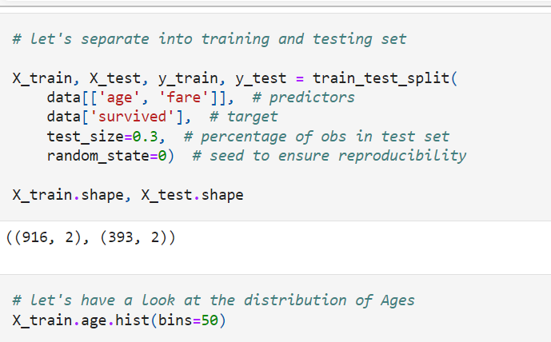

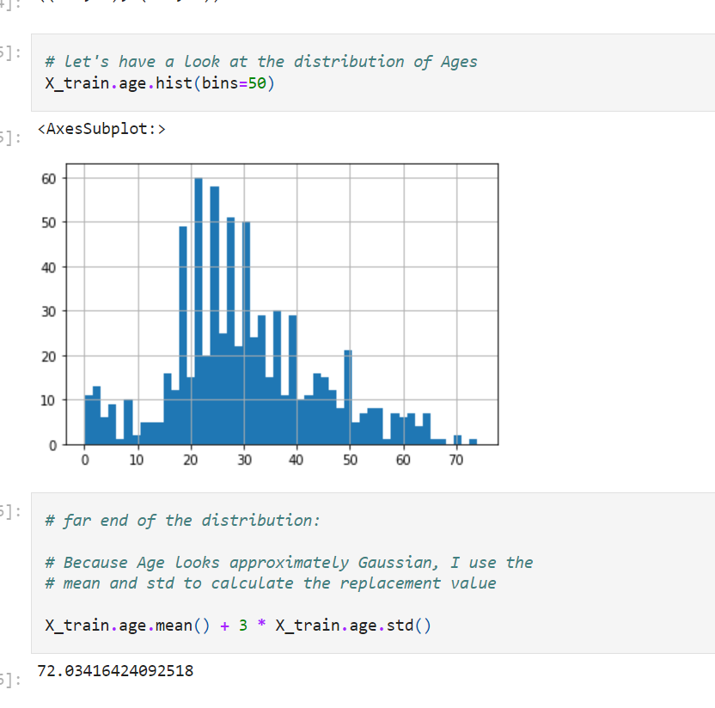

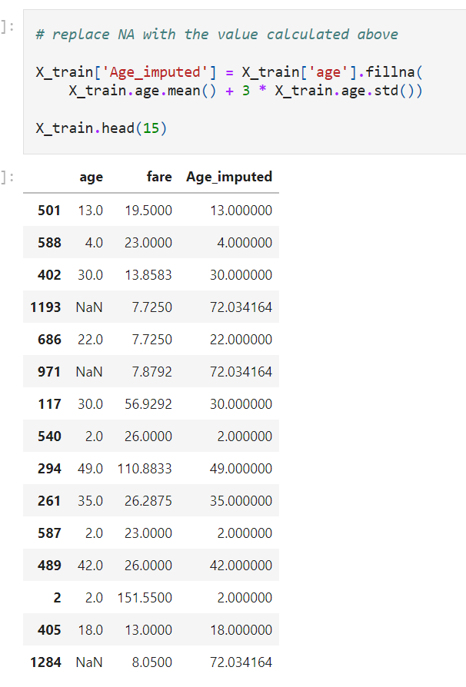

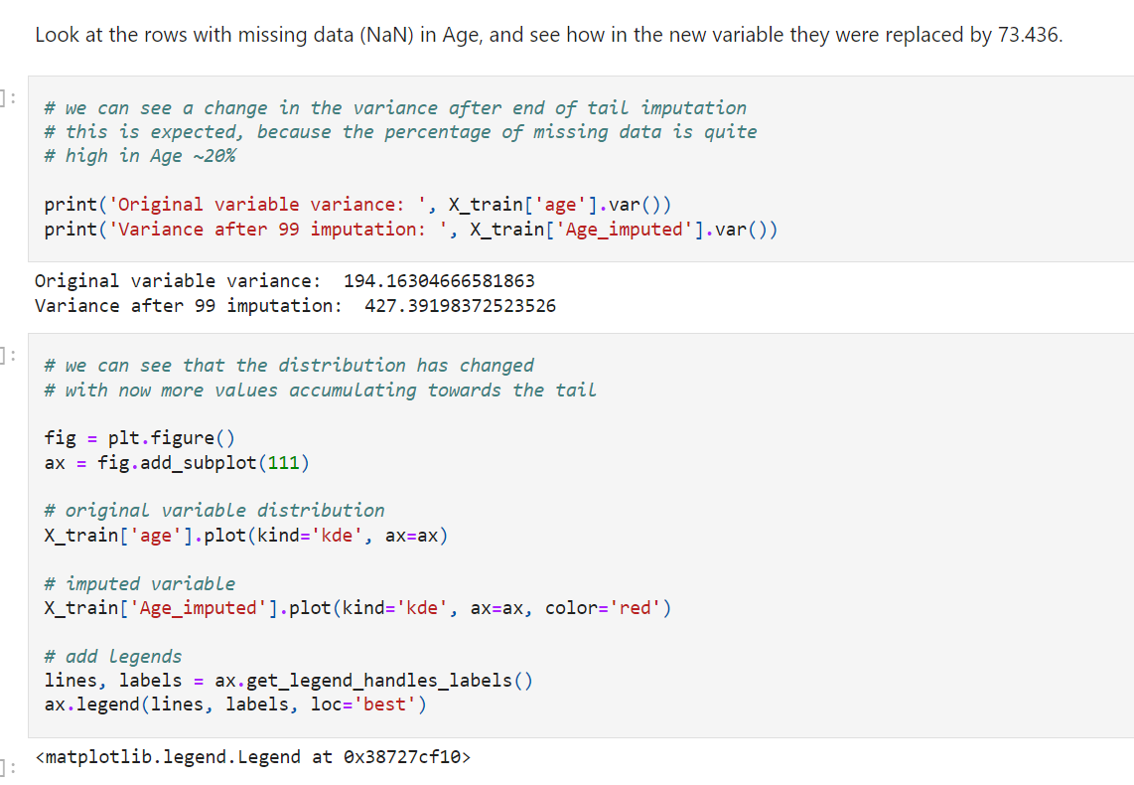

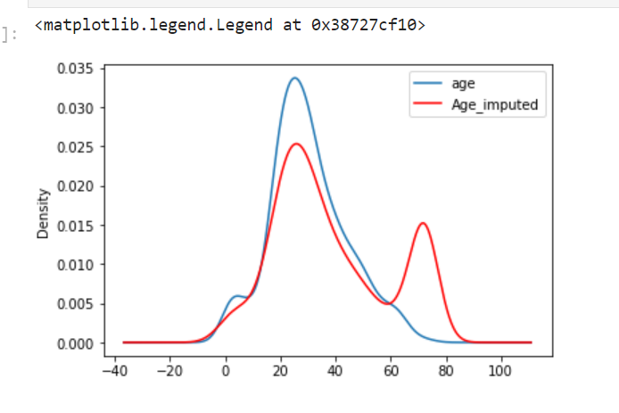

End-of-tail imputation, like arbitrary value imputation, **distorts the original distribution** of the variable Age.The transformed variable shows **more values around the selected tail value.**

**Is this important?**

It depends on the machine learning model you want to build. **Linear models** assume that the variables are **normally distributed**.

**End of tail imputation** may **distort the original normal distributio**n if the percentage of missing data is high. Therefore, the final imputed variable will no longer be normally distributed, which in turn may affect the linear model performance.

On the other hand, this technique works quite well with **tree-based algorithms**.

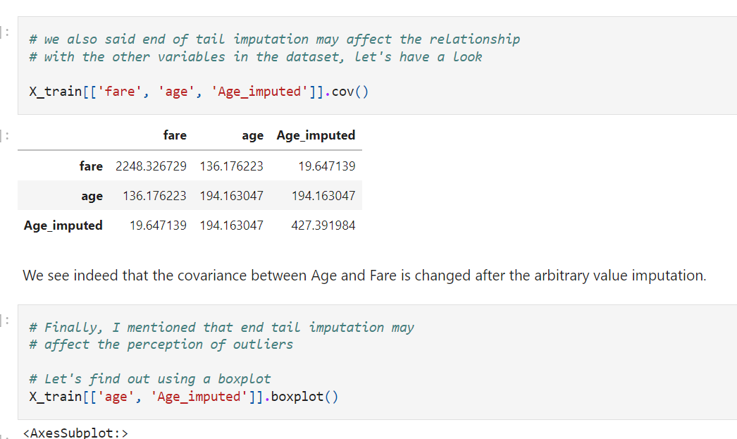

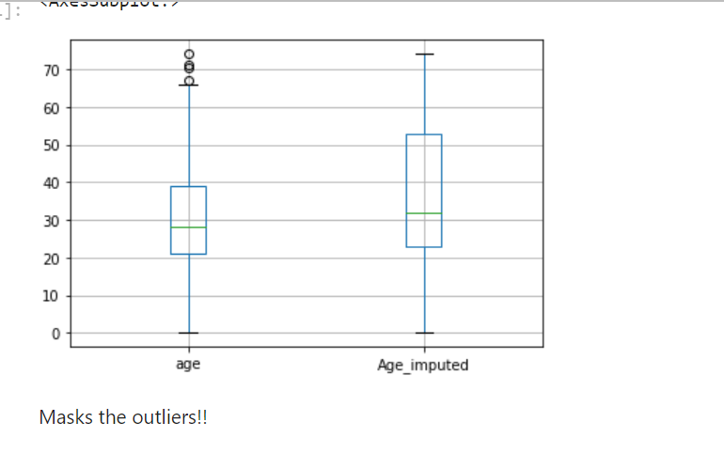

[feature-engineering-for-machine-learning/04.04-End-Distribution-Imputation.ipynb at main · solegalli/feature-engineering-for-machine-learning · GitHub](https://github.com/solegalli/feature-engineering-for-machine-learning/blob/main/Section-04-Missing-Data-Imputation/04.04-End-Distribution-Imputation.ipynb)

**Frequent category imputation | Mode imputation**

Imputation is the act of replacing missing data with statistical estimates of the missing values. The goal of any imputation technique is to produce a **complete dataset** that can be used to train machine learning models.

Mode imputation consists of replacing all occurrences of missing values (NA) within a variable by the mode, which is the **most frequent value** or **most frequent category**.

**Which variables can I impute with the most frequent category?**

Although the **mode can be calculated for both numerical and categorical variables**, in practice, we only **use this method on categorical variables**.

The rationale for this is that for numerical variables, the **mean or median tend to better represent the population's average value.**

**Assumptions**

* **Data is missing completely at random**

If data is missing at random, the value for the missing observation **will most likely look like the majority of the observations**, that is, the most frequent category of the variable.

**Advantages**

* Fast way of obtaining complete datasets
* Can be integrated into production (during model deployment)

**Limitations**

If the fraction of NA is large:

* **Distortion the relation of the most frequent category** with other variables
* Over-representation of **the most frequent category**

**When to use mode / most frequent category imputation?**

* Data is missing completely at random
* No more than 5% of the variables contain missing data

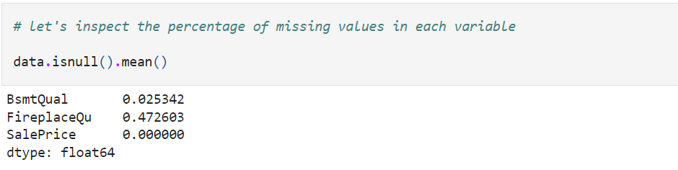

The variable **BsmtQual contains only a few observations** with NA (2.5), therefore, replacing those observations with the value of **the most frequent category is a good approach.**

On the other hand, the variable **FireplaceQu, contains missing data in almost half of the observations.** Therefore, **replacing those with the most frequent category** is most likely going to **distort the relationship of the most frequent category** with the sale price.

In addition, if so many observations in **FireplaceQu are missing**, it could be for a reason and not just at random, so we could be better off capturing that somehow with a different imputation technique. We will see how in the next notebook. For now, let's explore the effect of replacing NA by the most frequent categories when missing data is few or a lot.

**Imputation important**

**Imputation should be done over the training set,** and then **propagated to the test set.** This means that the most frequent category has to be selected from the training set, and used to replace NA both in train and test sets.

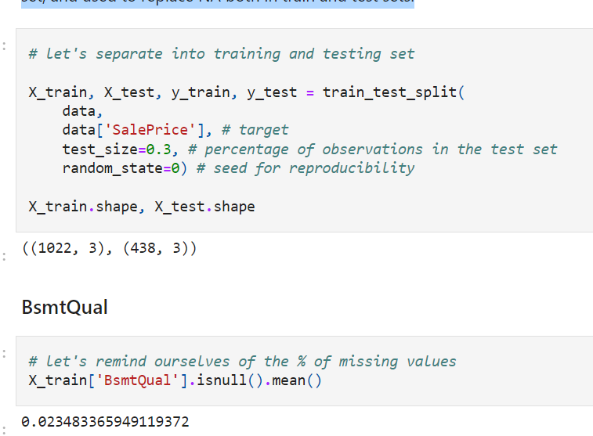

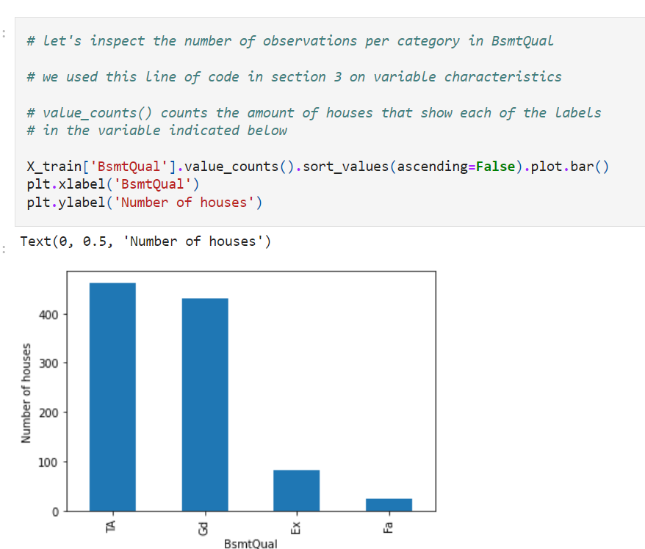

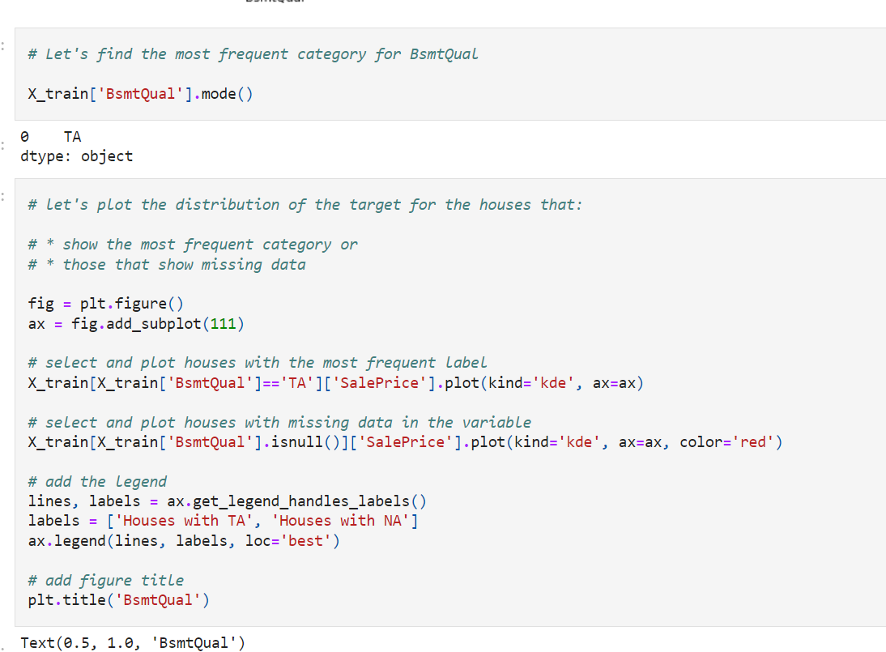

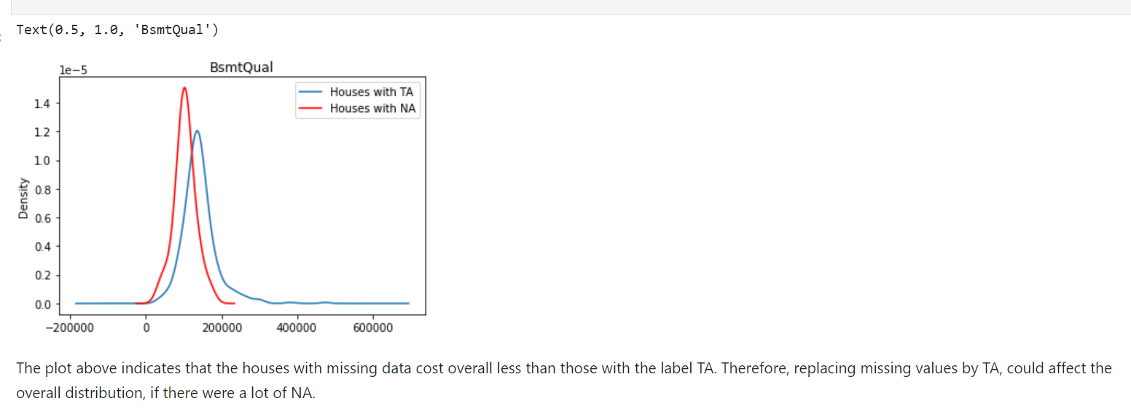\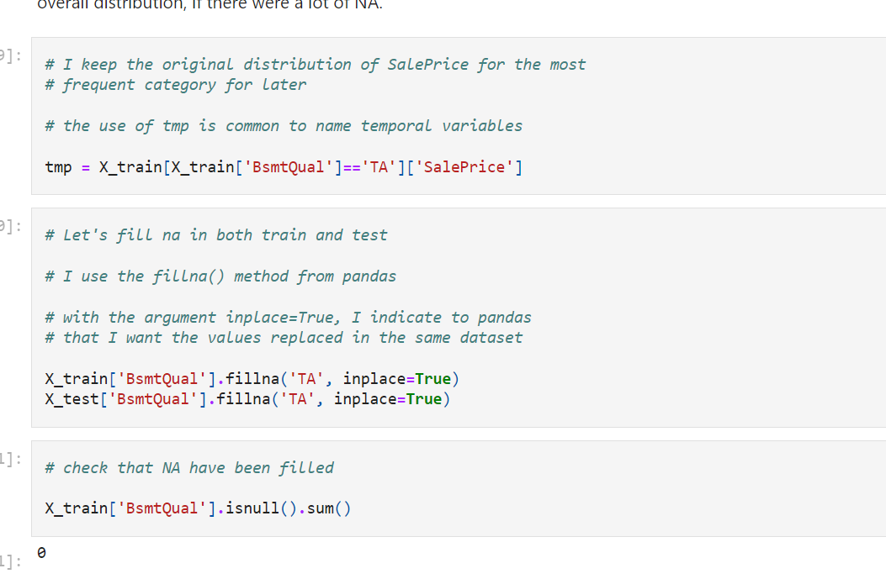

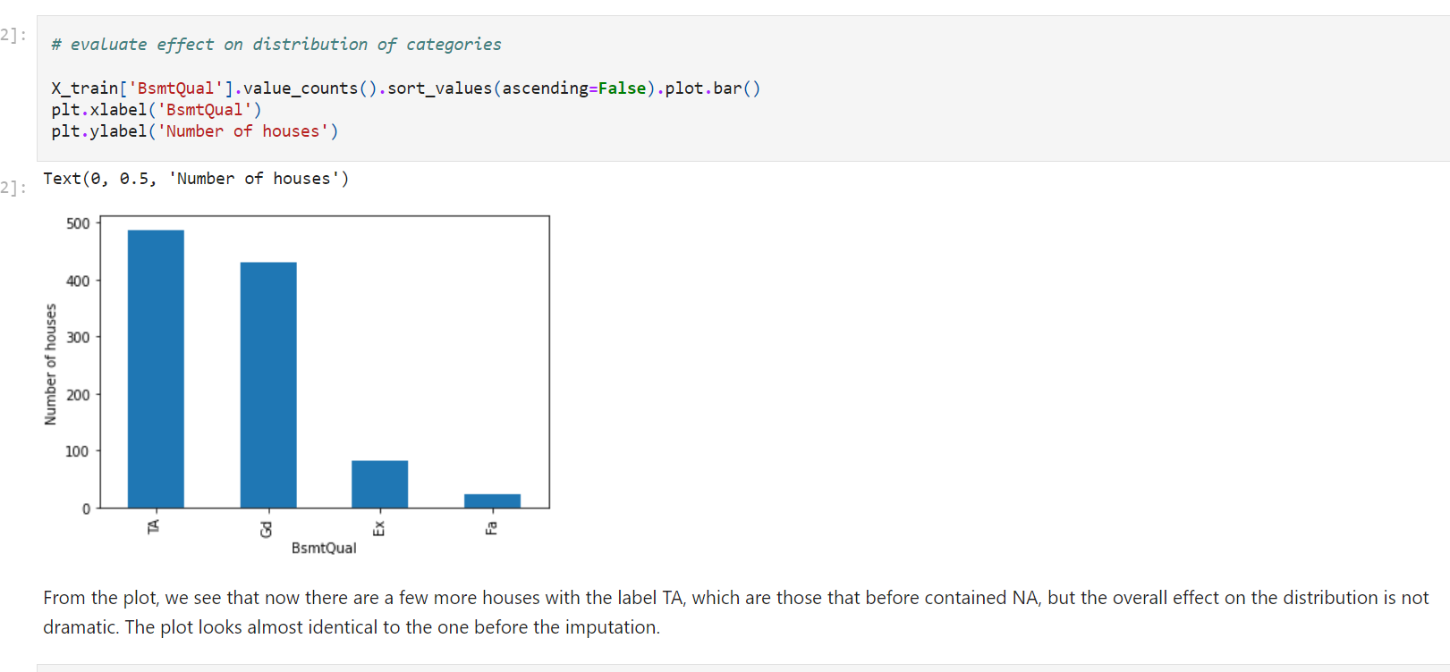

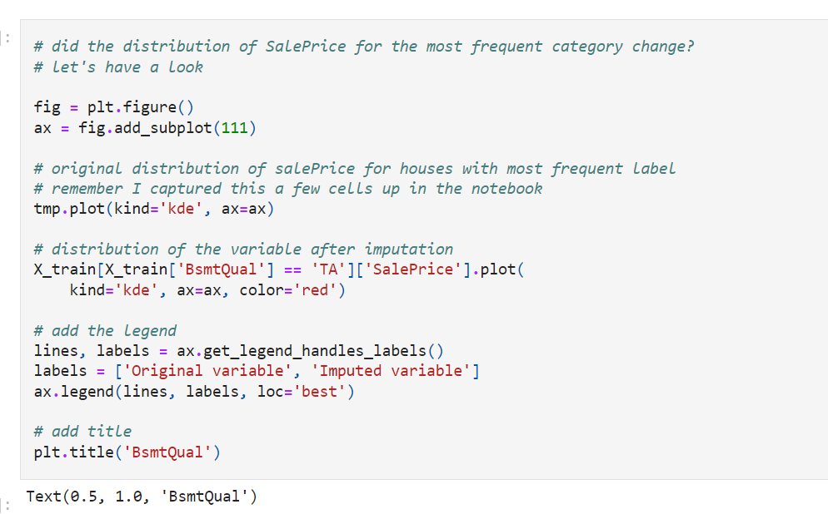

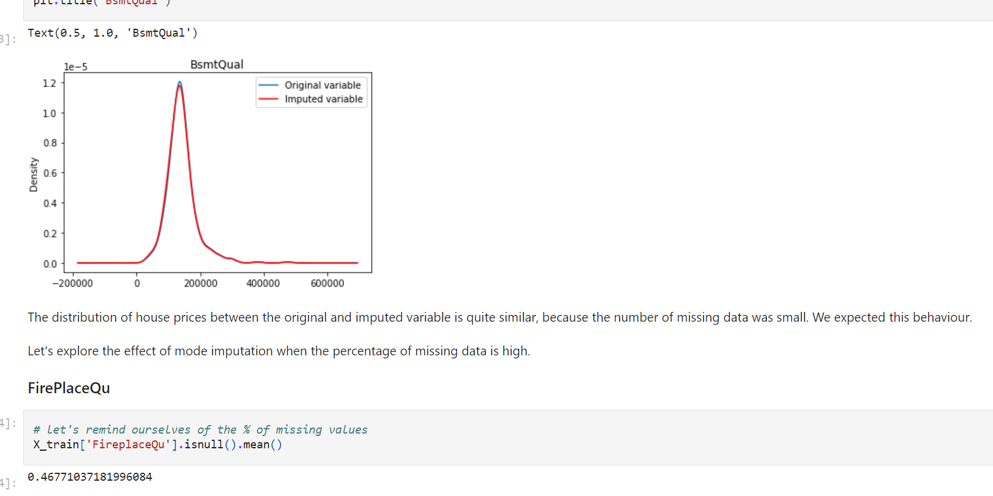

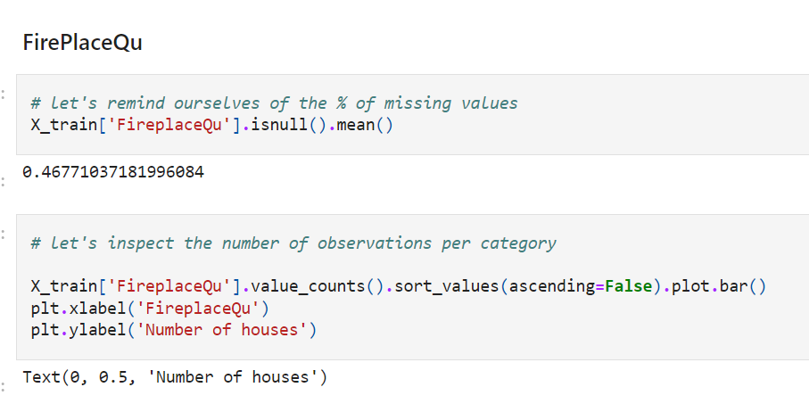

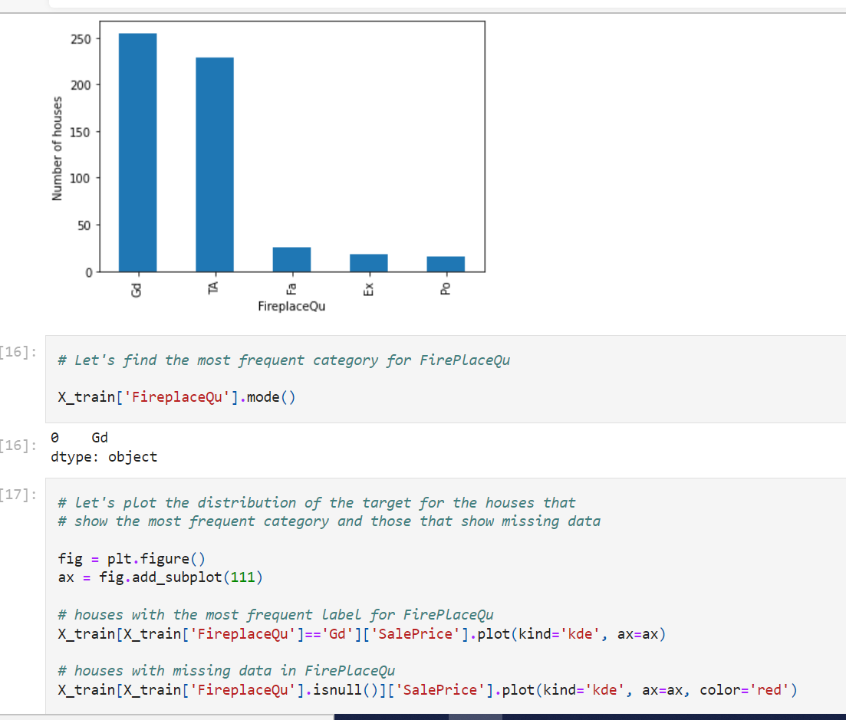

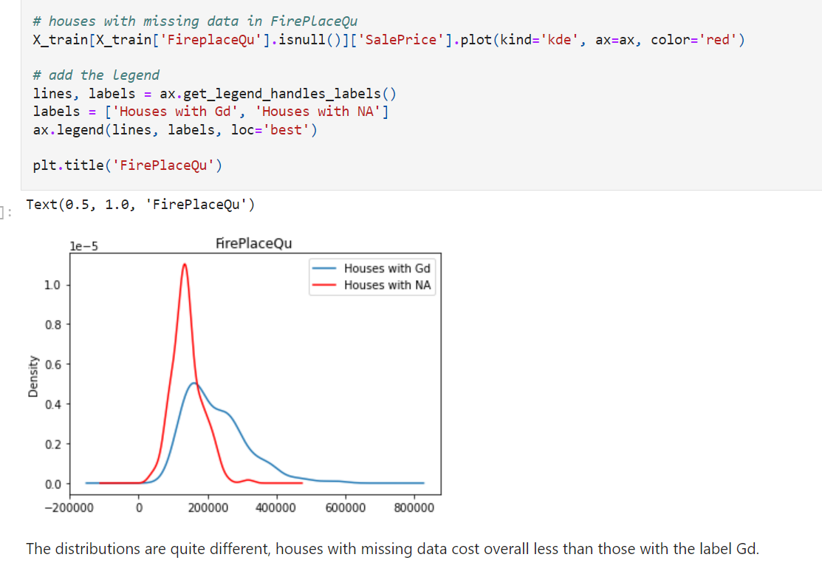

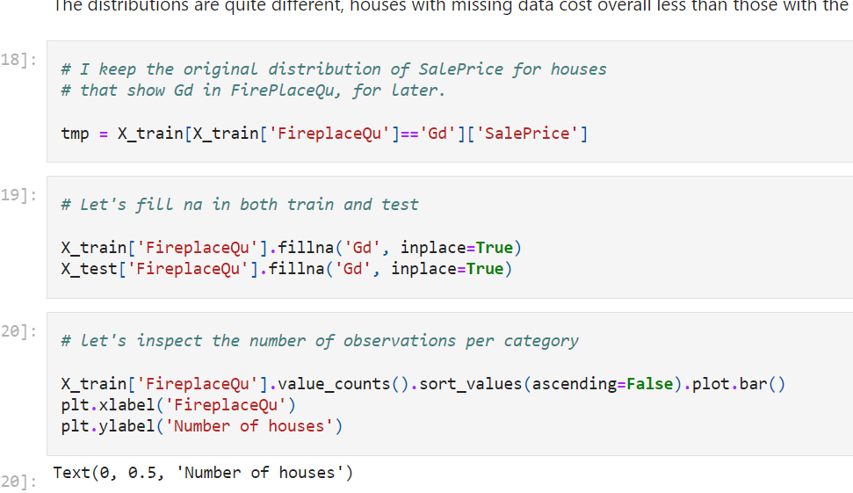

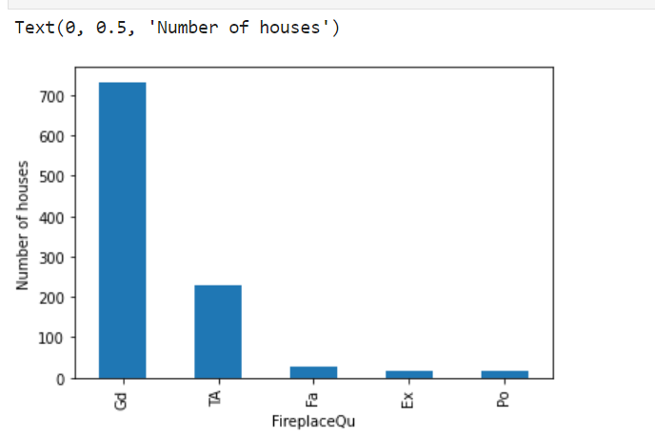

In this case, we see **a large distortion in the original distribution of the variable**.

Now we have a **lot more houses that contain the variable Gd**, compared to the houses that show the other variables.

Originally, half of the observations in FirePlaceQu were missing. **Now, all of those values contain Gd**. That is why we observe a big increase in Gd in the bar plot.

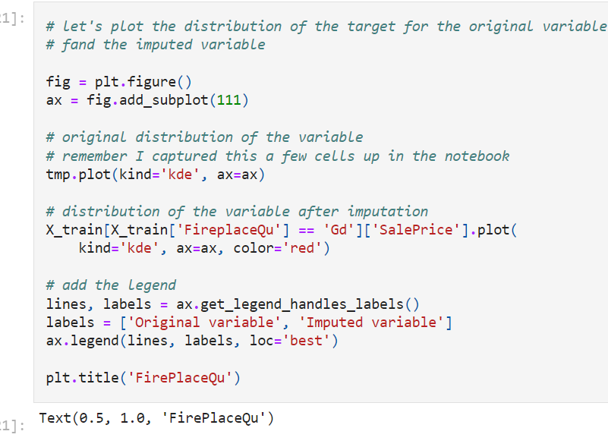

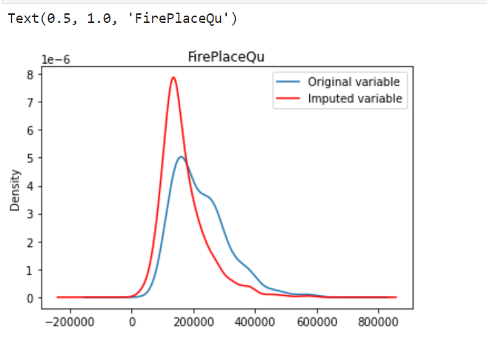

The average house value for the most frequent category has decreased quite dramatically after adding the house values of the NA, following the re-categorisation of NA as the most frequent label.

Thus, the importance of this particular label for the prediction of house prices is masked or changed by the addition of missing values.

In cases like this, when the percentage of missing values is so high (50%), we are better off creating a new category to enclose the observations with NA. I will show this in the next lecture.

**That is all for this demonstration. In later sections I will show you how to do mode imputation with scikit-learn and feature engine as part of a machine learning pipeline.**

Mode:

**Arbitrary value imputation for categorical variables**

This is the **most widely used method** of missing data imputation for categorical variables.

This method consists of **treating missing data** as an

**additional category of the variable**.

For example, all the **missing observations are grouped** under the newly created **label, "Missing'.**

This is, in essence, the **equivalent of replacing numerical variables** with **an arbitrary value.**

The beauty of this technique resides in the fact that it **does not assume anything about the fact that the data is missing.** It is very well **suited when the number of missing data points is high**.

**Advantages**

* Fast way of obtaining complete datasets
* Can be **integrated into production** (during model deployment)
* **Highlights missing data**
* No assumption made on the data

**Limitations**

* **If the number of NA is small**, **creating an additional** category may introduce **noise**

For **categorical variables,** this is the **method of choice,** as it treats missing values as a **separate category**, without making any assumptions about the variable or the reasons why data could be missing. It is widely used in data science competitions and organisations. See, for example, the winning solution of the KDD 2009 cup: "Winning the KDD Cup Orange Challenge with Ensemble Selection"

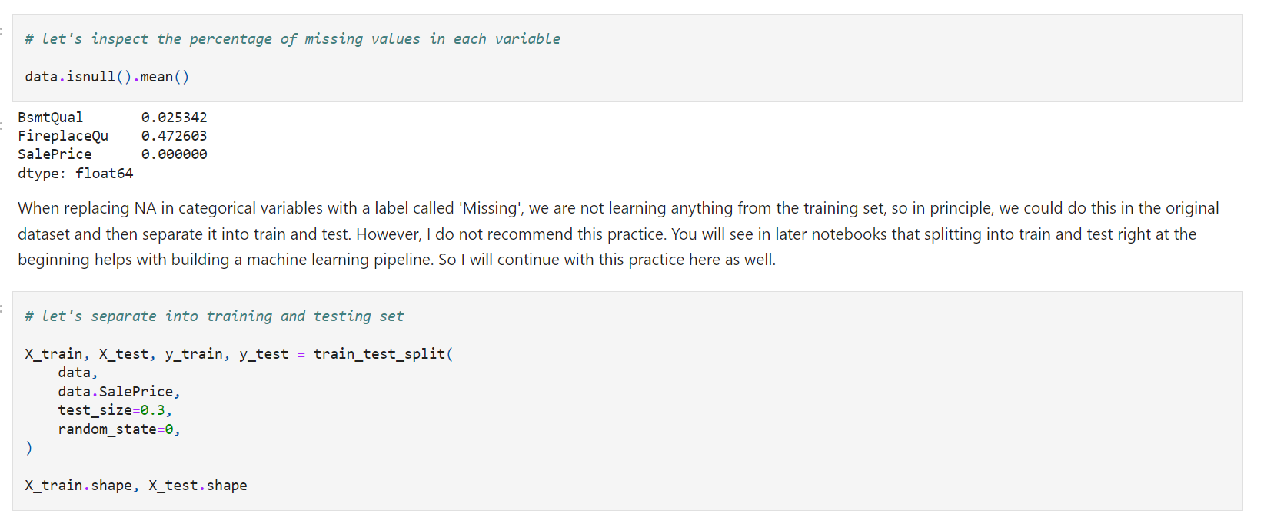

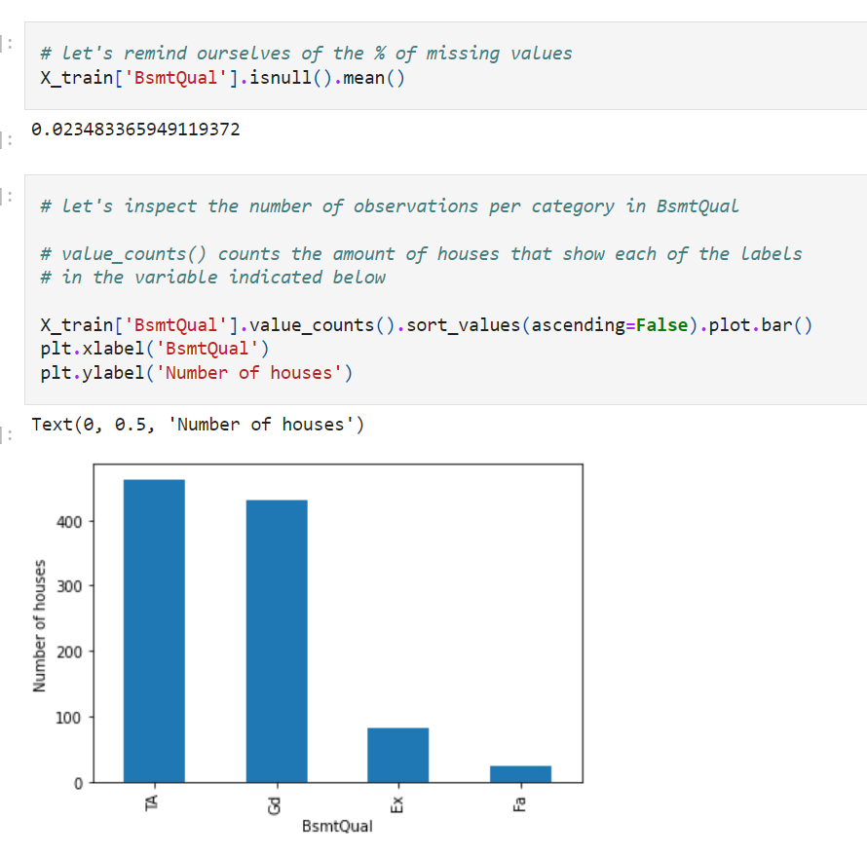

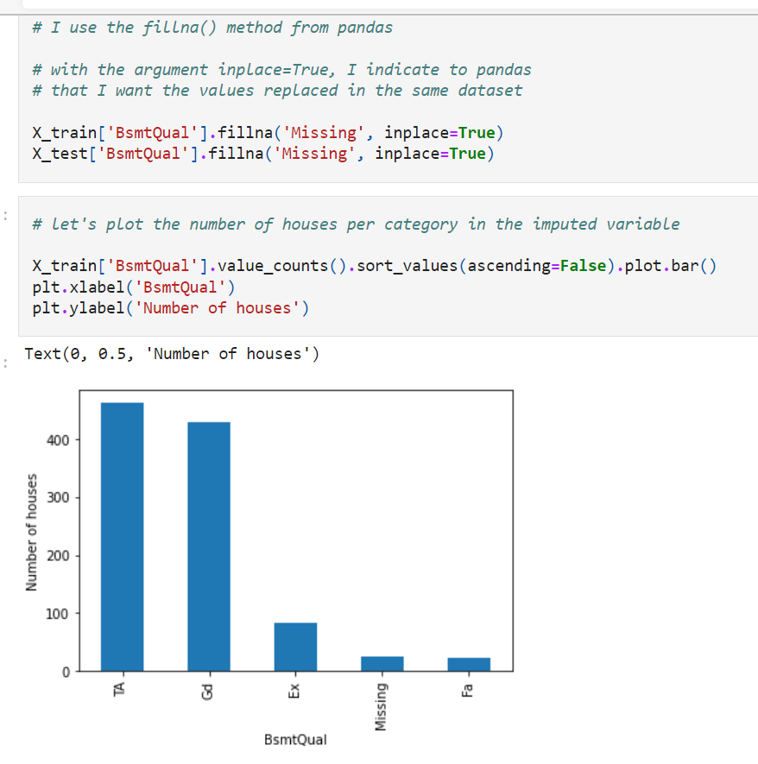

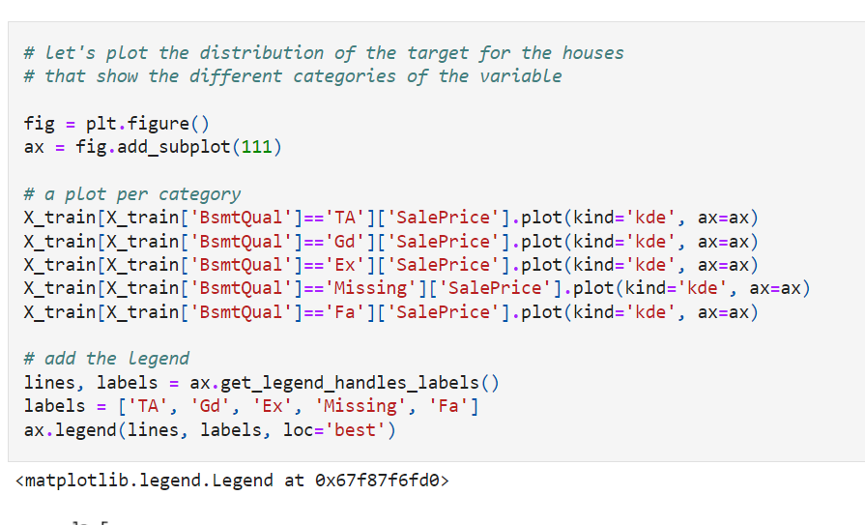

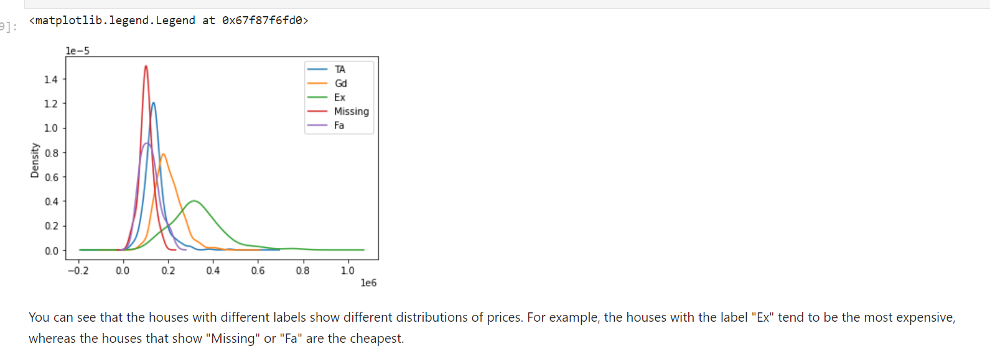

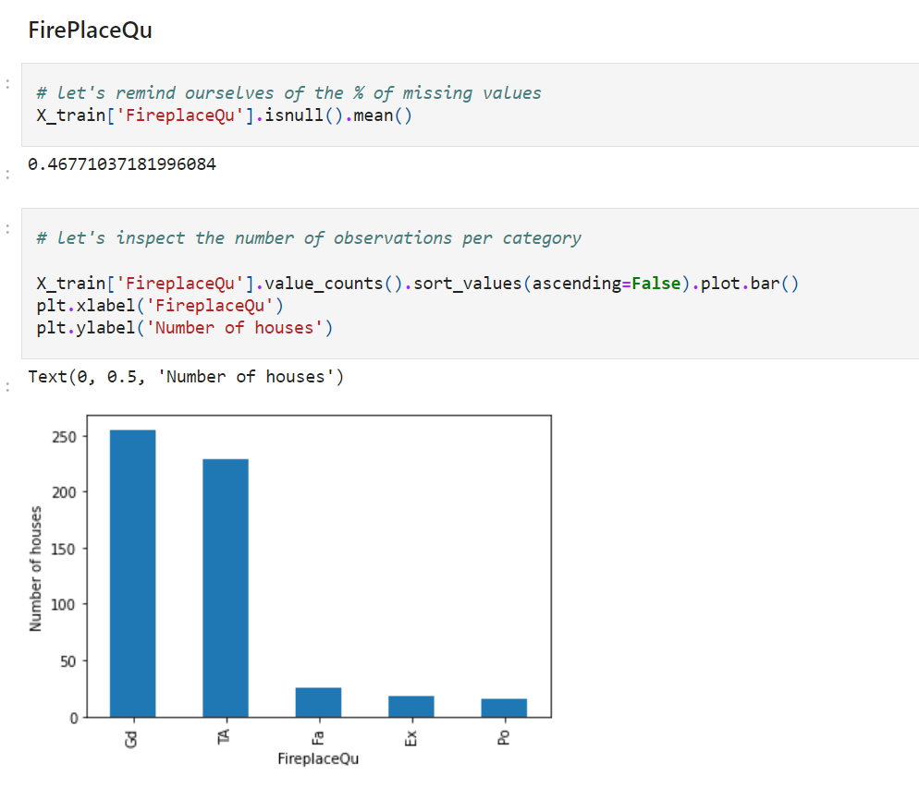

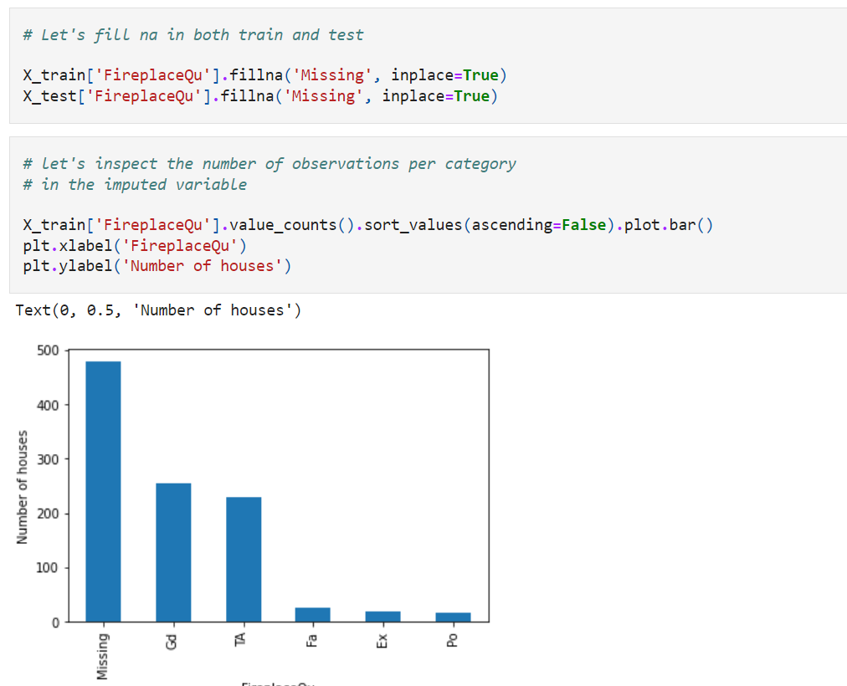

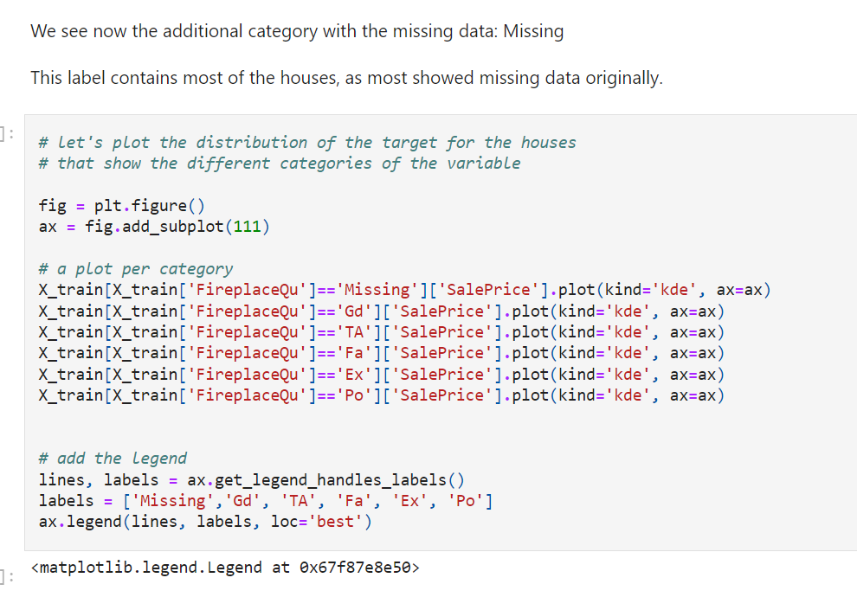

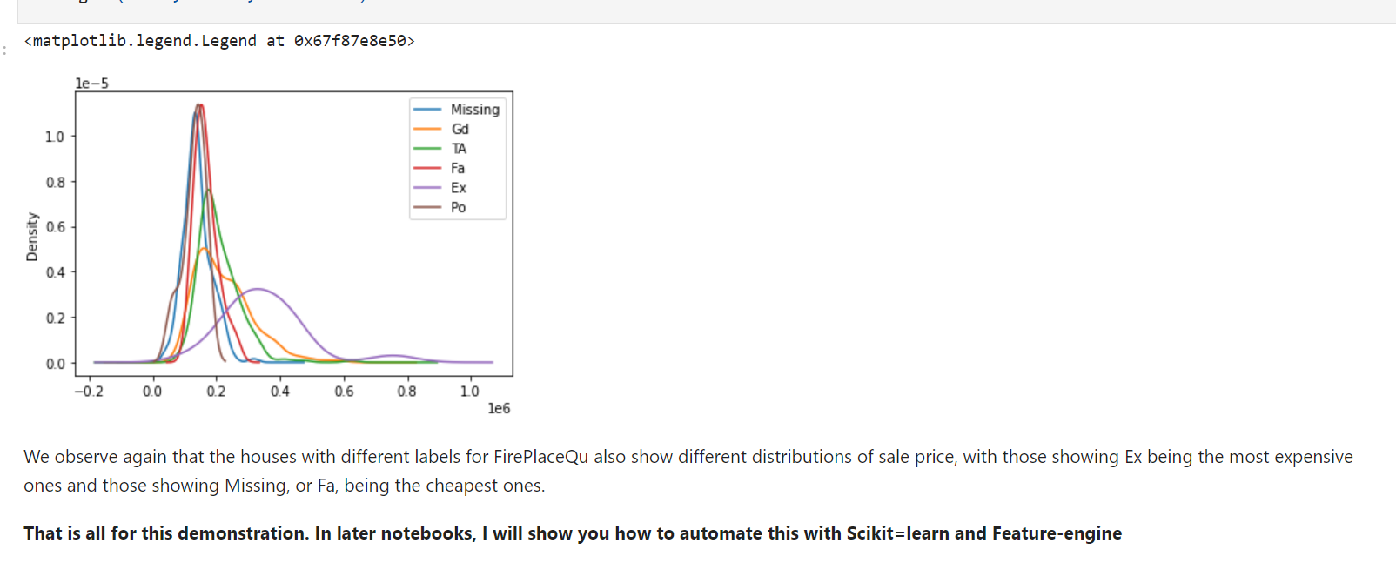

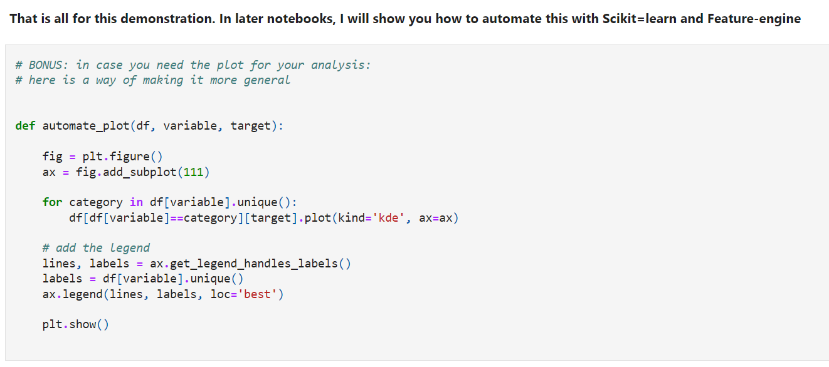

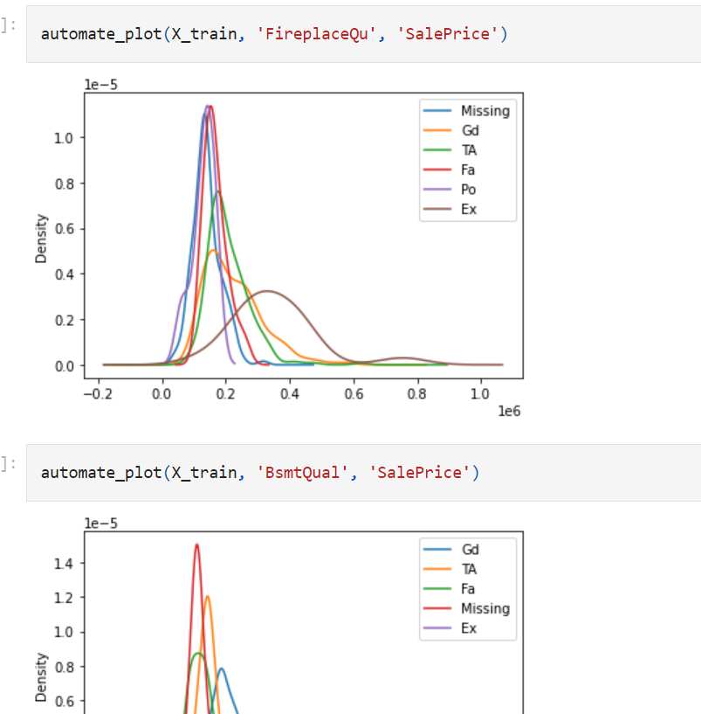

**Random sample imputation**

Imputation is the **act of replacing missing data** with statistical estimates of the missing values. The goal of any imputation technique is to produce a **complete dataset** that can then be used for machine learning.

Random sampling imputation is in **principle similar to mean, median, and mode** imputation in that it considers that missing values, **should look like those already existing in the distribution**.

Random sampling consists of **taking random observations from the pool of available data** and **using them to replace the NA.**

In random sample imputation, **we take as many random observations as missing values** exist in the variable.

In both **numerical and categorical variables**,

the **distribution of the variable is preserved** by sampling observations at random to replace missing data.

**Which variables can I impute by random sample imputation?**

Random Sample Imputation can be applied to both **numerical and categorical variables**.

**Assumptions**

Random sample imputation assumes that the **data is missing completely at random**. In this scenario, it makes sense to substitute the missing values with values extracted at random from the original distribution.

From a probabilistic point of view, **values that are more frequent**, like the **mean or the median or the most frequent category**, will be selected more often -because there are more of them to select from-, **but less frequent values will be selected as well**. Thus, the distribution of the variables is preserved.

In essence, we replace a population of missing values with a population of values with **the same distribution of the original variable.**

**Advantages**

* Preserves the **variable distribution**

**Limitations**

* **Randomness**
* The relationship of **imputed variables with other variables may be affected if there are a lot of NA**
* **Computationally more expensive** than previous methods
* **Memory heavy for deployment**, as we need to **store the original training set, to extract values to replace the NA.**

**When to use Random Sample Imputation?**

* Data is **missing completely at random**
* **No more than 5% of the variables contain missing data.**
* Well **suited for linear models as it does not distort the distribution**, regardless of the percenage of NA

If used in combination with missing indicators, then this method can be used when data is not missing at random, or when there are many missing observations.

**Randomness**

Randomness may not seem much of a concern when replacing missing values for data competitions, where the whole batch of missing values is replaced once, and then the dataset is scored and that is the end of the problem. However, in business scenarios, the situation is very different.

Imagine, for example, a car manufacturer is trying to predict how long a certain car will be in the garage before it passes all the security tests. Today, they received a car with missing data in some of the variables. They ran the machine learning model to predict how long this car would stay in the garage. The model replaces missing values by a random sample and then produces an estimate of time. Tomorrow, when they run the same model on the same car, the model will randomly assign values to the missing data that may or may not be the same as the ones it selected today. Therefore, the final estimation of time in the garage, may or may not be the same as the one obtained the day before.

In addition, imagine the car manufacturer evaluating two different cars that have exactly the same values for all of the variables, and missing values in exactly the same subset of variables. They run the machine learning model for each car, and because the missing data is randomly filled with values, the 2 cars, that are exactly the same, may end up with different estimates of time in the garage.

This may sound completely trivial and unimportant. However, businesses must certain regulations, and some of them require the same treatment to be provided in the same situation. So if instead of cars, these were people applying for a loan, or people seeking disease treatment, the machine learning model would provide different solutions to candidates that are in the same conditions. And this is not fair or acceptable. This behavior needs to be avoided.

**So, should we randomly replace NA or not?**

It is still possible to replace missing data by random sample, but this randomness needs to be controlled, so that individuals in the same situation end up with the same scores and, therefore, with the same solutions offered. How can we ensure this? by appropriately setting seeds during the random extraction of values.

Finally, a disadvantage of random sampling, similar to the use of the mean and median, is that estimations of covariance and correlations with other variables in the dataset may be distorted, especially if there are many missing observations.

**Final note**

Replacement of missing values by a random sample, although similar in concept to replacement by the median or mean, is not as widely used in the data science community as the mean/median imputation, presumably because of the element of randomness, or because the code implementation is not so straightforward.

However, it is a valid approach, with clear advantages over mean or median imputation, as it preserves the distribution of the variable. And, especially for linear models, if you are aware of the element of randomness and account for it in some way, this may be the approach of choice.

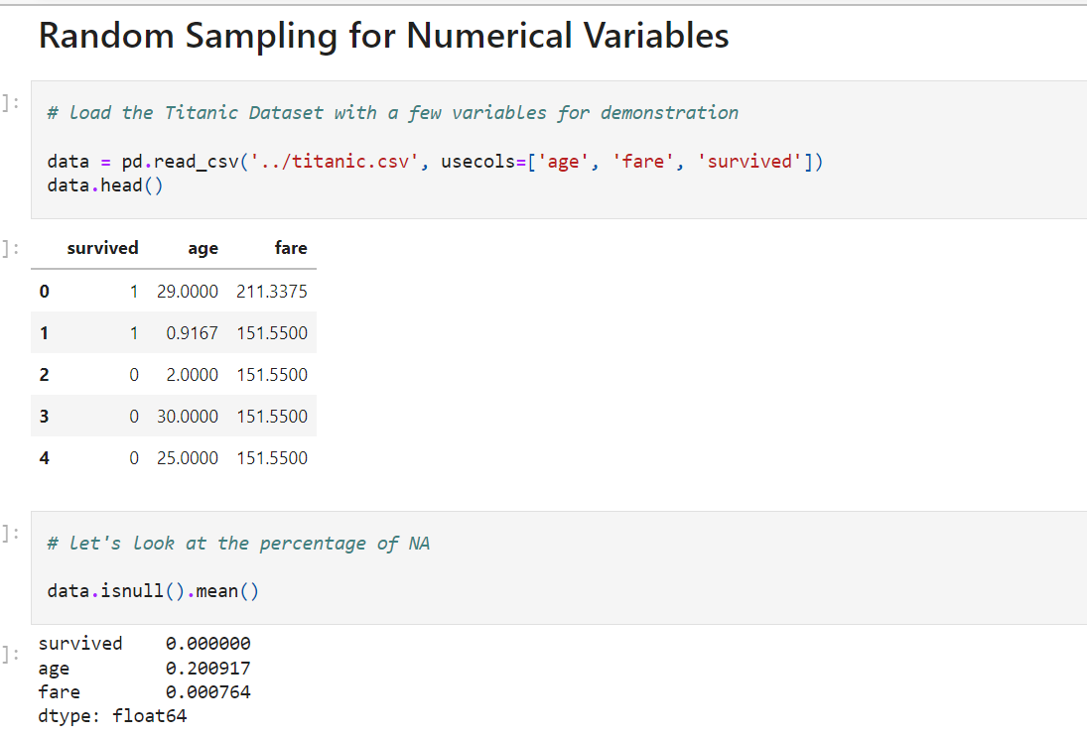

**Imputation important**

Imputation should done over the training set, and then propagated to the test set. This means that the random sample to be used to fill missing values both in train and test set, should be extracted from the train set.

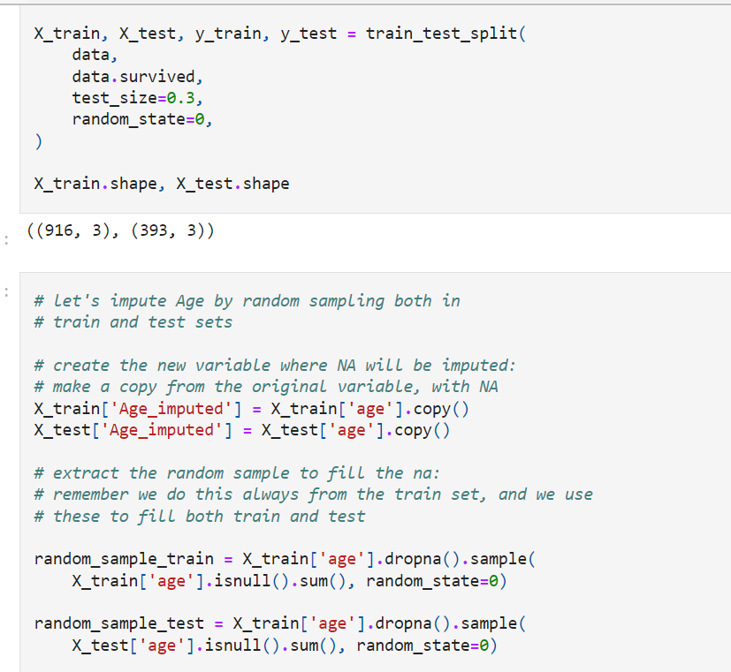

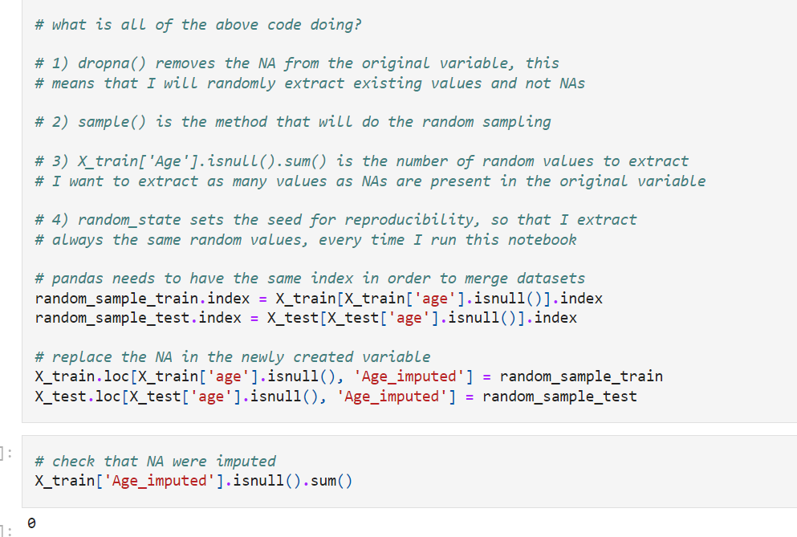

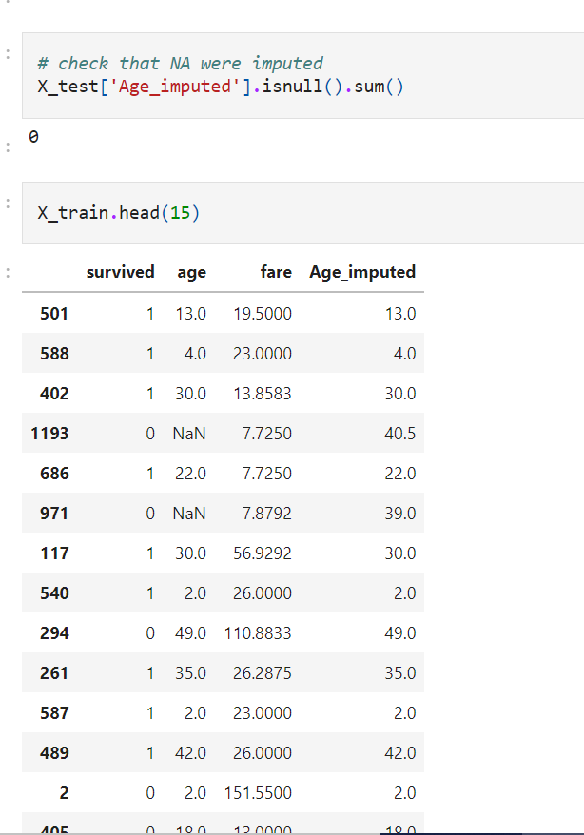

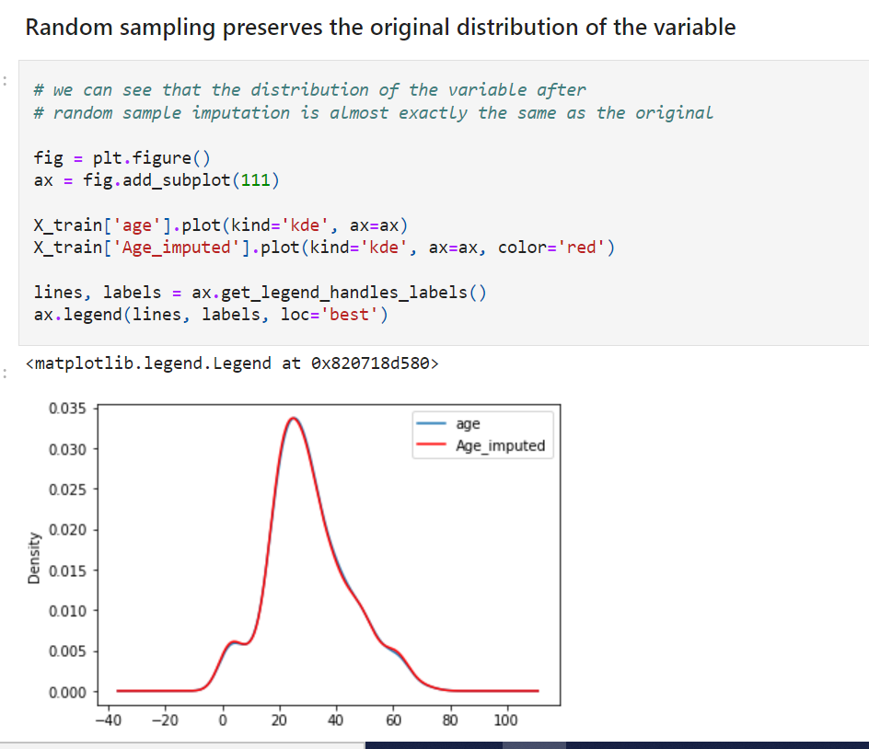

We can see that replacing missing values with a random sample from the training set **preserves the original distribution of the variable**. If you remember from previous notebooks, every other imputation technique altered the distribution of Age, because the percentage of NA in Age is high, ~20%. However, random sample imputation preserves the distribution, even in those cases. So this imputation technique is quite handy, **if we are building linear models** and we don't want to distort normal distributions.

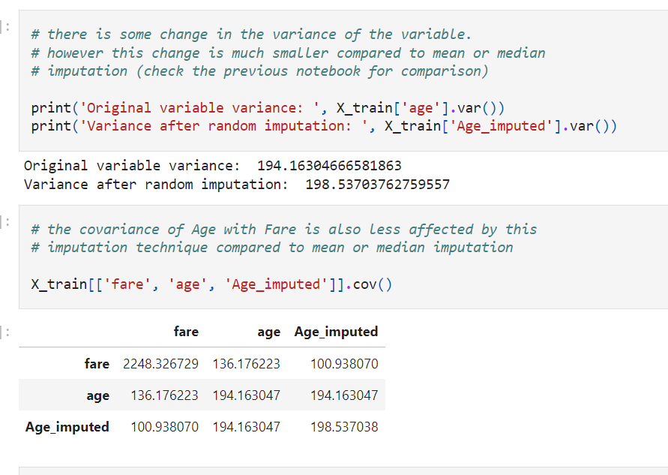

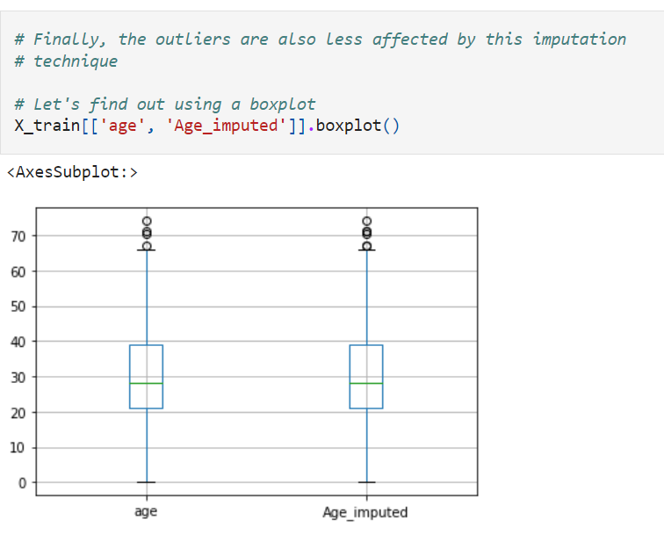

So, random sample imputation offers all the **advantages provided by the preservation of the original distribution.** And that is a big plus, particularly, if you care about distribution and outliers for your machine learning models. This is **particularly relevant for linear models**. but not so important for tree based algorithms.

**Randomness can lead to different scores being assigned to the same observation**

Let's examine the **effect of randomness on multiple scoring**, and how we can mitigate this behaviour, as this is very important when putting our models in production / integrating our models with live systems.

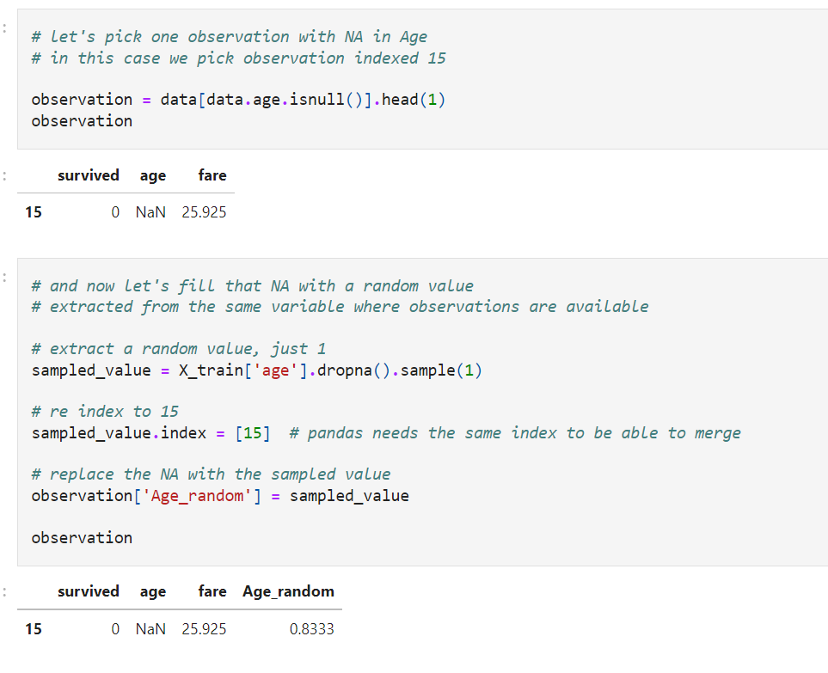

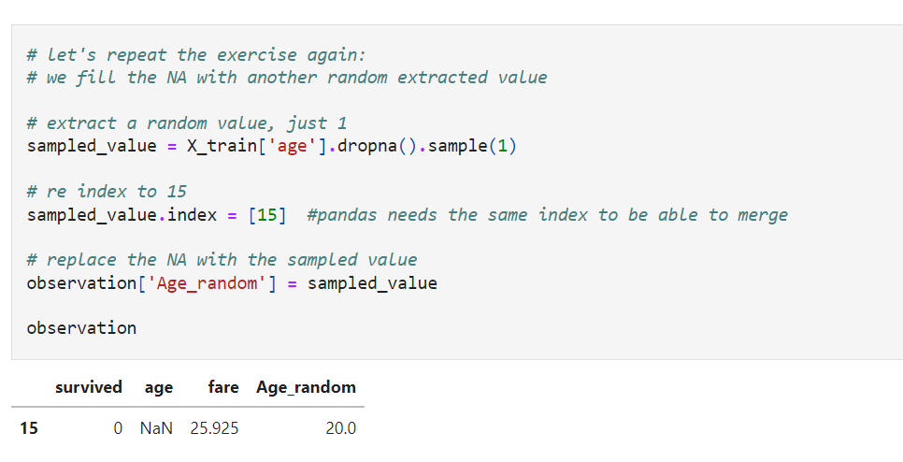

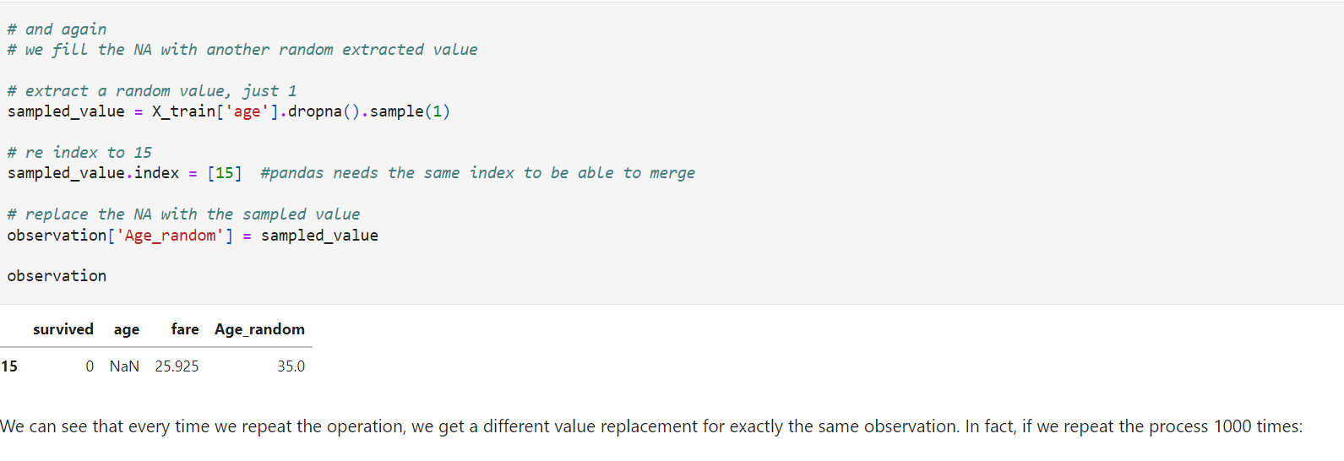

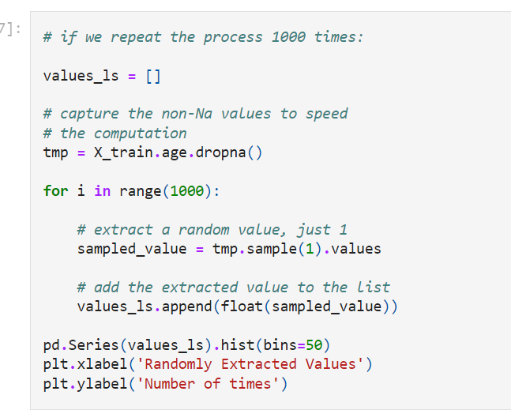

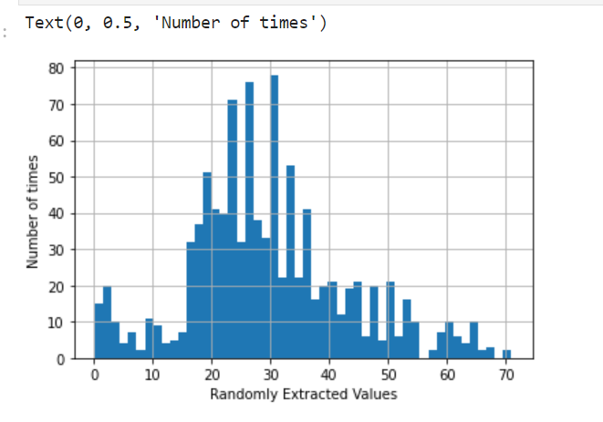

Still need to read

**Adding a variable to capture NA**

In previous notebooks, we learned how to replace missing values by the **mean, median, or by extracting a random value**.  These methods assume that the data is **missing completely at random (MCAR).**

There are other methods that can be used when values are **not missing at random**, for example, **arbitrary value imputation or end of distribution imputation**. However, these imputation techniques will affect the variable distribution quite dramatically, and they are **therefore not suitable for linear models.**

**So what can we do if the** data is not MCAR **and we want to use linear models?**

If data are not missing at random, it is a **good idea to replace missing observations with the mean, median, or mod**e while **flagging** them with a **Missing Indicator**.A missing indicator is a binary variable that indicates whether the data was missing (1) or not (0).

**For which variables can I add a missing indicator?**

We can add a missing indicator to both numerical and categorical variables.

**Note**

Adding a **missing indicator is never used alone**.

On the contrary, it **is always used together with another imputation technique**, which can be **mean / median imputation** for **numerical variables,** or **frequent category imputation for categorical variables.** For both categorical and numerical variables, we can combine random sample imputation with the addition of a missing indicator.

Commonly used together:

* Mean/median imputation + missing indicator (Numerical variables)
* Frequent category imputation + missing indicator (categorical variables)
* Random sample imputation + missing indicator (numerical and categorical)

**Assumptions**

* Data is **not missing at random**
* Missing data is **predictive**

**Advantages**

* **Captures the importance of missing data** if there is one

**Limitations**

* Expands **the feature space**

Adding a missing indicator **will increase the number of variables** in the dataset. So if the dataset contains 10 features, and all of them have missing values, after adding a missing indicator, we will have a **dataset with 20 features**: the **original 10 features plus an additional 10 binary features**, which indicate for each of the original variables whether they were missing or not. This may not be a problem in datasets with tens to a few hundred variables, but if our original dataset contains thousands of variables, by creating an additional variable to indicate NA, we will **end up with very big datasets.**

In addition, data tends to be missing across multiple variables, which often leads to many of the missing indicators being similar to or even identical to each other.

**Final note**

Typically, mean / median / mode imputation is done together with adding a variable to capture those observations where the data was missing, thus covering 2 angles: if the **data was missing completely at random**, this would be contemplated by the mean / median / mode imputation, and if it wasn't, this would be captured by the missing indicator.

These methods combined are the top choice in data science competitions. See, for example, the winning solution of the KDD 2009 cup: ["Winning the KDD Cup Orange Challenge with Ensemble Selection](http://www.mtome.com/Publications/CiML/CiML-v3-book.pdf).

